
Upper Mississippi River Restoration Program
Completion Report
2021HG7

Mapping Potential Sensitivity to Hydrogeomorphic Change in the UMRS Riverscape
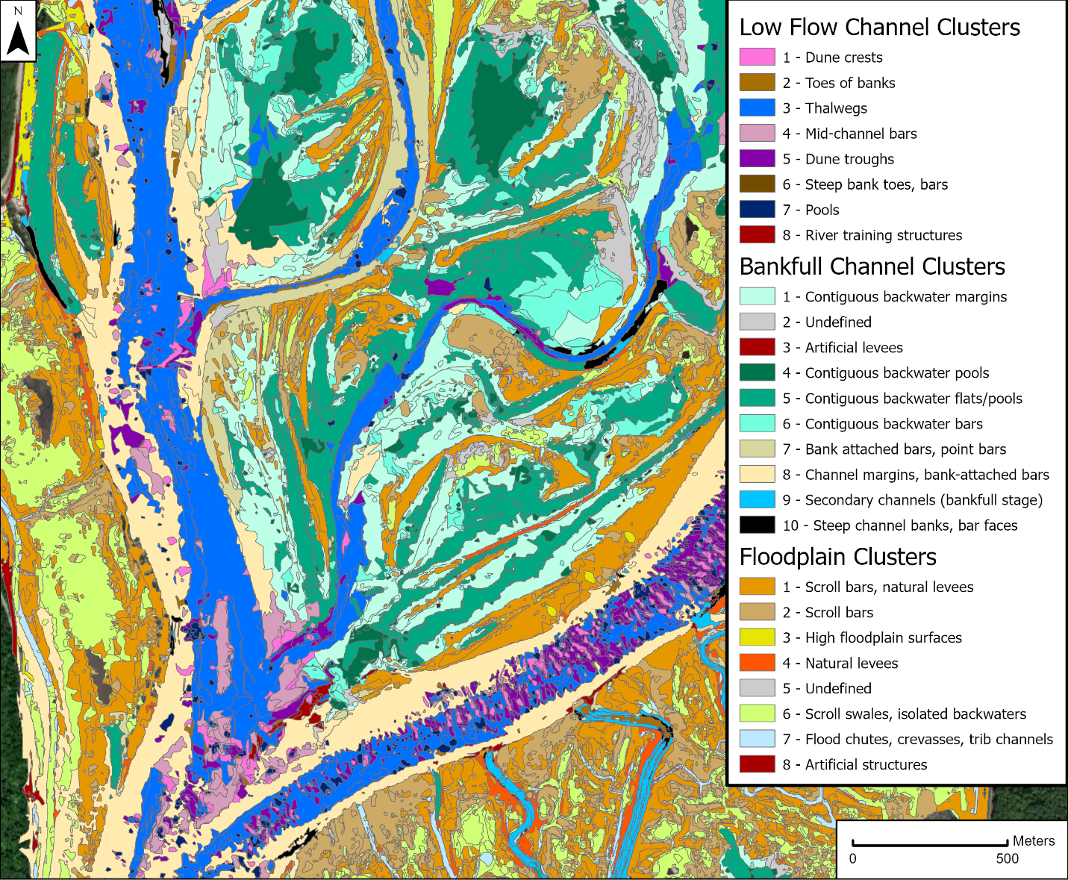
September 2025
Mapping Potential Sensitivity to Hydrogeomorphic Change in the UMRS Riverscape

Angus Vaughan¹, Faith A. Fitzpatrick², Jayme Strange¹ and Molly Van Appledorn¹
¹ U.S. Geological Survey, Upper Midwest Environmental Sciences Center, 2630 Fanta Reed Road, La Crosse, WI 54603, USA
² U.S. Geological Survey, Upper Midwest Water Science Center, 1 Gifford Pinchot Drive, Madison, WI 53726, USA

Abstract

In 2020 the U.S. Geological Survey (USGS), as part of the Upper Mississippi River Restoration (UMRR) Program, began a new project to characterize potential hydrogeomorphic change associated with hydrogeomorphic units (HGUs) and their catenae (units linked by their association with sediment sources and flow origins). The goal of the project was to develop a geographic information system (GIS) database of HGUs for the Upper Mississippi River System (UMRS) available to both scientists and river managers working on UMRR studies and HREP planning and design studies. The characterization was based on a hydrogeomorphic change hierarchical classification developed previously for the UMRS. The products were generated with automated techniques in a GIS using systemic datasets. Landforms were mapped from the 2015 UMRS topobathymetric dataset with geomorphon (shape-based) tools tailored for the large riverscape, valley bottom environments in the UMRS. A clustering analysis was applied to the resulting landforms to identify HGUs associated with zones of perennial low flows, bankfull flows, and overbank floodplains. Catenae were assembled based on the proximity of the units to the main channel, tributary mouths, and side channels from previously published aquatic areas (USACE, 2018) coupled with least-cost flowpath linkages between potential sediment origins and planform change units developed by Rogala, Fitzpatrick, and Henderson (2020). These GIS-based analyses were successful at identifying a range of HGUs using an automated technique with available data across the entire riverscape, with emphasis on those that have the potential for hydrogeomorphic change. Most of the resulting features are depositional, as expected in a large river system. However, this is the first attempt of linking tributary inputs, side channel erosion and levee breaches with their depositional counterparts. The approach was successfully piloted in Pools 8 and 10 in the Upper Impounded Reach and Pool 14 in the Lower Impounded Reach, with next steps for application in reaches of the unimpounded section and Illinois River. This report emphasizes results from Pool 10, which was the focus of most of our attention during the pilot phase.

Background

Understanding the processes, rates, and spatial patterns of hydrogeomorphic change within the Upper Mississippi River System (UMRS) has been the motivation for a significant amount of monitoring and research and is an ongoing focus for guiding management decisions within the river system (Houser, 2022) (fig. 1). Hydrogeomorphic change results from the interactions of hydrology, hydraulics, and sediment dynamics at a variety of spatial and temporal scales. To provide a context for synthesizing information on hydrogeomorphic processes and change across the system and a framework for understanding future change, from 2018-20 a core team of USGS and USACE scientists and engineers developed a conceptual model and hierarchical classification system (Fitzpatrick et al., 2022) (fig. 2). The model and classification were developed after a review of relevant prior research, geographic information system (GIS)-based data sets, and the broader literature on diagnostic-style process-based classification systems (Fryirs, 2003; Brierley and Fryirs, 2005; Buffington and Montgomery, 2013; Montgomery and Buffington, 1993). The classification framework contains six hierarchical levels that describe the boundary conditions and drivers impacting hydrogeomorphic conditions and change across a range of spatial and temporal scales important to the UMRS riverscape (fig. 2). In a complementary development, a GIS-based data set of depositional areas was recently mapped for the Upper Impounded reach (Van Appledorn and Rogala, 2022). The data set was derived from planform change mapping of five bar types situated above the perennial water level in the river system based on analyses of land cover data over two time periods 1989-2000 and 2000-2010 (Rogala, Fitzpatrick, and Henderson, 2020). The bar types included crevasse deltas, tributary deltas, impounded delta, bar-tail limbs, and undifferentiated.
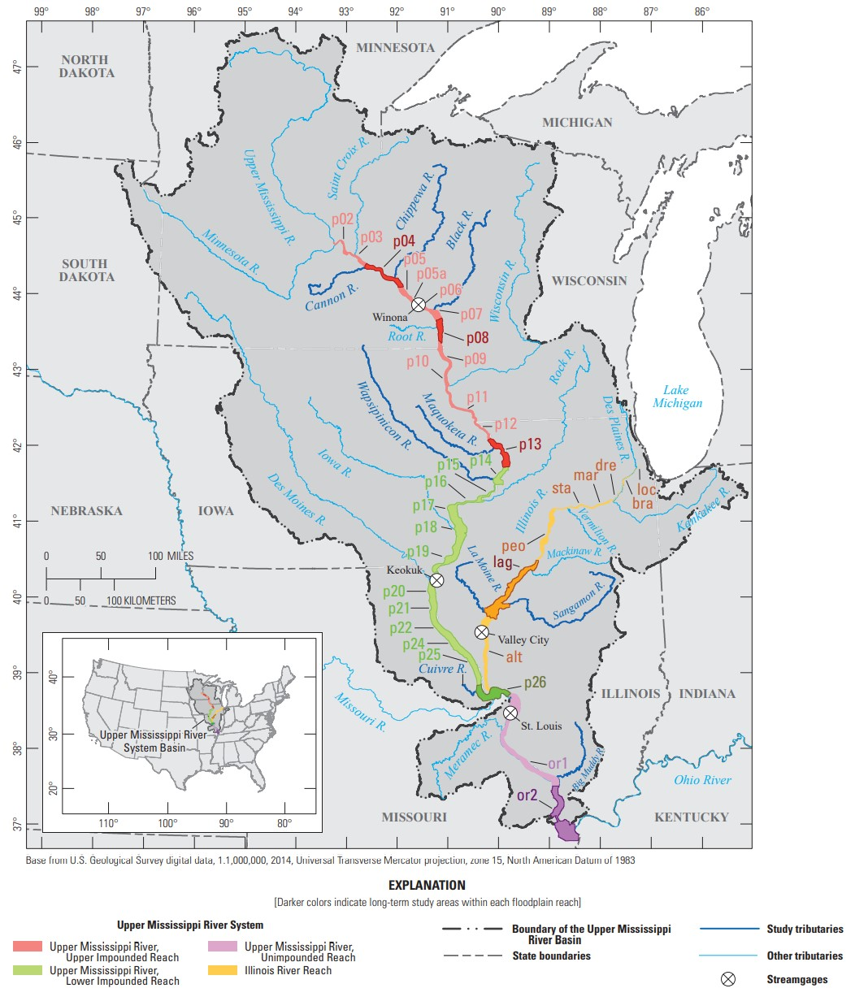
Figure 1. The Upper Mississippi River System, its major tributaries, and basin boundary. The four floodplain reaches are demarcated by color and navigation pools are numbered. From Houser et al., 2022; USACE, 2011.

With this study we developed the hierarchical framework into a geospatial database by mapping landforms at the two finest-scale levels of the classification – hydrogeomorphic units (HGUs) and catenae—HGUs grouped by geomorphic origin and process. Detailed, process-based classification and mapping of HGUs and catenae is possible in the UMRS because of the availability of high-resolution, river-wide topobathymetric data sets (USACE, 2016), basin-wide quantitative models on tributary sediment loads (USGS SPARROW Model; Robertson and Saad, 2019), flood inundation maps (Van Appledorn et al., 2018; 2021), and maps of depositional planform change (Rogala, Fitzpatrick, and Henderson, 2020). HGUs are the foundational level of the classification and form the building blocks of the valley bottom landscape, spanning the channel (e.g., bars, banks, riffles, pools) and floodplain (e.g., scroll ridges and swales, natural levees, crevasse channels, oxbows, terraces) (Table 1). Because HGUs are formed and reworked by a specific set of hydrogeomorphic processes, their identification and classification provide a basis for interpreting the origin of the landform, potential processes affecting the form (erosional or depositional), and the type of expected change and sensitivity to change (Fryirs and Brierly, 2021). In many cases, characteristic assemblages or reach-scale spatial relationships of HGUs occur within rivers of similar geomorphic type and setting, and many HGUs are linked by erosional and depositional process relationships (Fryirs and Brierly, 2021; Belletti et al., 2017). These process-based linkages of HGUs compose the second level of the classification, hydrogeomorphic catenae.
HGUs have distinct morphologic properties and hydraulic/hydrologic settings that together can be used to classify and map them. These features include three-dimensional form, position on the valley bottom, relationship to channel flows of varying energy and recurrence, and sedimentary composition and structure (Fryirs and Brierly, 2021; Wheaton et al., 2015; Belletti et al., 2017; Gurnell et al., 2016). In response to the increasing availability of high-resolution topography and other remotely sensed data, multiple automated and semi-automated approaches have been developed for mapping and classifying HGUs and geomorphic features at broader scales. Automated, rule-based mapping of geomorphic features has several advantages over mapping by hand from remotely sensed data or by field mapping. Such methods are more efficient and repeatable, enabling mapping at a finer scale (i.e., that of individual HGUs) over a much broader area (i.e., the entire UMRS) than would be possible by manual mapping. Additionally, by standardizing classification criteria and metrics, subjectivity in interpretation is reduced (Williams et al., 2020; Wheaton et al., 2015).

One approach to automated geomorphic feature detection is the application of the “geomorphon” concept. Geomorphons are fundamental, distinct landform morphologic elements, which are mapped in an automated fashion through a machine vision and pattern recognition algorithm (Jasiewicz and Stepinski, 2013). The approach has been used to create and interpret a geomorphic map of Poland (Jasiewicz and Stepinski, 2013) and to delineate valley bottoms in a semi-automated way (Khan and Fryirs, 2020). The method is an entirely form-based approach, however, and requires additional interpretation to derive insight into geomorphic processes associated with the mapped features. Another approach is the Geomorphic Unit Tool (GUT; Bangen et al., 2017; Wheaton et al., 2015), which characterizes HGUs based on a tiered, hierarchical method. The base tier entails characterizing the position of an HGU within the channel or floodplain, which exerts a first-order control on the flow energy and sediment delivery processes experienced by a landform. Subsequent tiers add additional information about the form of the unit (convex, concave or planar; tier 2), the detailed morphometry, lateral position (mid-channel, bank attached), orientation, and hydraulic or structural forcing of the form (tier 3), and sedimentological and vegetative characteristics (tier 4). GUT has been applied to several areas in the Columbia River Basin to map HGUs for assessing stream restoration effectiveness, mapping stream reach type and condition, and assessing relationships between geomorphic unit assemblages and river network characteristics (Kramer et al., 2017). The GUT algorithm is open source and freely available, but currently limited to mapping in-channel HGUs, limiting its direct applicability for a large floodplain river like the UMR.
In this study, we adapted aspects of both the geomorphon and GUT methods to develop an automated approach to map landforms continuously throughout the valley bottom of the UMRS, including the channel and the floodplain. The geomorphons algorithm was applied to the river-wide topobathymetric data sets (USACE, 2016) to identify landforms that are the basis for HGUs. We added hydrogeomorphic process context to these form-based features using information from the aquatic areas ecosystem indicators dataset (Theiling et al., 2000; De Jager et al., 2018), floodplain inundation frequency (Van Appledorn et al., 2018; 2021) and other systemic datasets. Information about planform change and bar formation over two time periods between 1989 and 2010 (Rogala, Fitzpatrick, and Henderson, 2020) allowed for identification of depositional HGUs that are undergoing active and progressive change. We also used least-cost path methods across the topobathy dataset (USACE, 2016) to examine source-sink relationships between tributary and main-channel sediment sources estimated by the SPARROW model (Robertson and Saad, 2019) and depositional units, and transport pathways across the channel-floodplain interface. These methods were piloted in Pool 10 and subsequently run for Pool 8 and 14, with future plans to expand across the entire system. To focus the scope of this report, we limit ourselves here to reporting on the results from Pool 10. The report is structured around three complementary objectives, which include:
- Developing a GIS dataset that identifies HGU features and the attributes that define them from systemic datasets available for the UMRS.
- Identifying hydrogeomorphic catenae based on process linkages between the mapped HGUs.
- Exploring associations between HGU attributes and the location and mechanisms of depositional planform change to identify locations and settings that are sensitive to change and therefore potential priorities for management actions.

UMRS hydrogeomorphic setting and conceptual model

The UMRS is defined as the commercially navigable portions of the main stem Mississippi River north of Cairo, Illinois, and its tributaries, including the Illinois River. It drains a basin covering 500,000 square kilometers (Fig. 1). It is a large, lowland floodplain river system, comprising an often-multi-thread channel network; large floodplains; and lotic environments including backwaters, floodplain lakes, and impounded areas upstream of dams (Houser, 2022). As with other large, lowland river systems, it is broadly dominated by depositional environments within channels, backwaters, and floodplain surfaces (Fitzpatrick et al., 2022; Lewin et al., 2016; Belby, 2005).
There is a large body of scientific research and monitoring for the (UMRS) concerning long and short-term changes in hydrogeomorphic patterns, processes, and rates of change (e.g., Gaugush, 2004; Belby; 2005; Rogala, Fitzpatrick, and Henderson, 2020; Rogala, Kalas and Burdis, 2020). Drivers of change identified by the conceptual model for the UMRS (Fitzpatrick et al., 2022) include upstream hydrology and flow conditions, tributary flows and sediment loads, water level changes, and local velocity variations that contribute to erosion and deposition. The style and potential for hydrogeomorphic change is a function of factors including proximity to tributaries and dams, valley and channel slope and width, channel confinement, local variations in vegetative roughness, and hardened structures added for navigation and rehabilitation. Typical processes related to change include channel bed aggradation and lateral migration, island head erosion, floodplain sedimentation, backwater filling, delta/fan development, and bar and island tail growth (Fitzpatrick et al., 2022; Rogala, Fitzpatrick, and Henderson, 2020).
The drivers and boundary conditions that impact patterns of erosion, sediment transport, and deposition vary longitudinally along the UMRS. Consequently, the UMRS cumulative effects study (WEST Consultants, Inc., 2000) characterized the drivers important for hydrogeomorphic change across four floodplain reaches and 12 geomorphic reaches, which were adopted as levels of the classification system (Fitzpatrick et al., 2022; Fig. 2). The floodplain reaches – Upper Impounded, Lower Impounded, Unimpounded, and Illinois River – are defined by variation in longitudinal and lateral hydrologic connectivity driven by natural and anthropogenic factors such as impoundment, floodplain geomorphology and land use (with resulting impacts on degree of levying), as well as channel planform, longitudinal profile, and hydrology. The geomorphic reaches are determined by broad-scale valley and floodplain morphology, and major slope breaks in the longitudinal profile (Fig. 3).

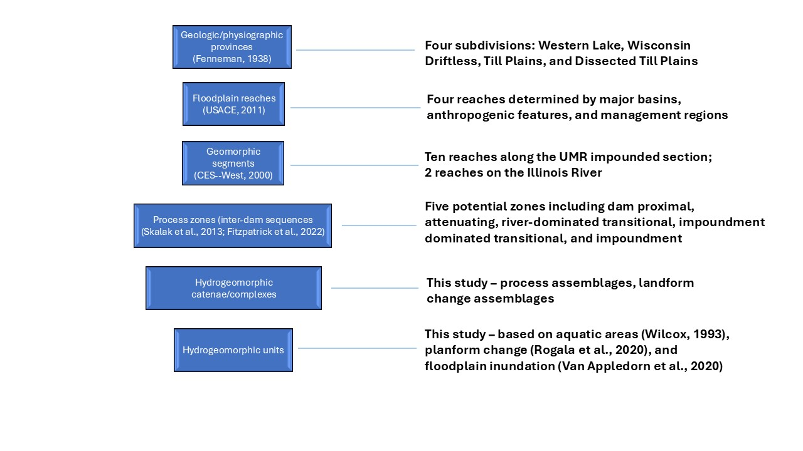Figure 2. Summary of the conceptual hierarchical classification system of the UMRS (Fitzpatrick et al., 2022).

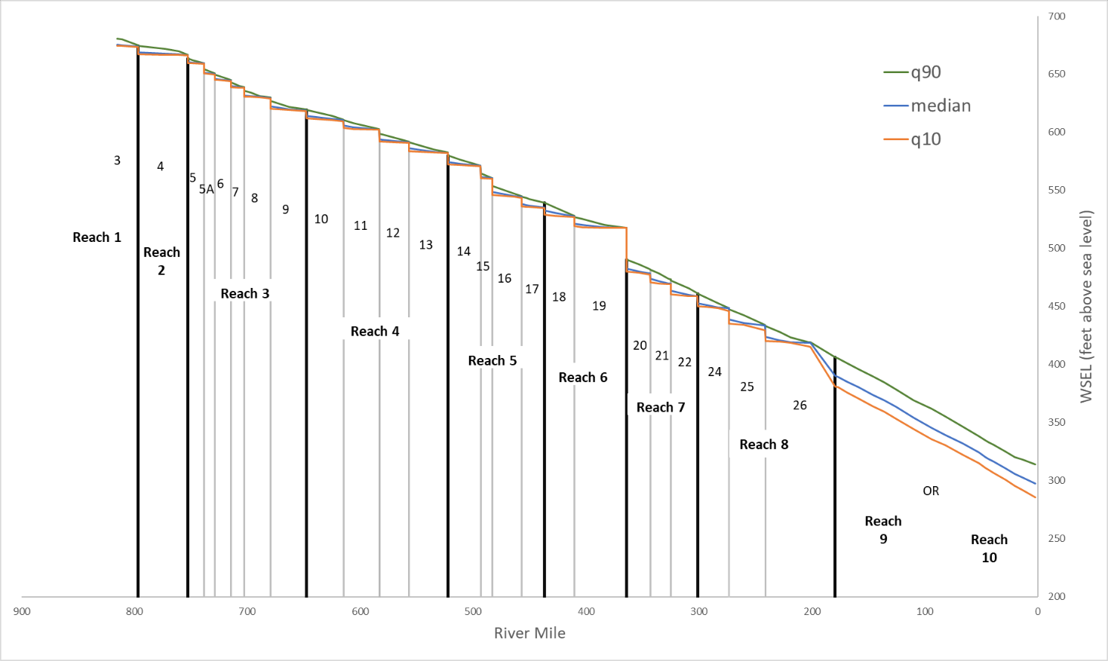Figure 3. Longitudinal profile of the UMR, developed from USACE stream gage water surface elevation (WSEL) data from 1972-2011. Profiles are shown for three flow stages, high flow (90 percent exceedance, q90); median; and low flow (10 percent exceedance, q10). Because of the effects of the lock and dam structures, WSEL slope varies significantly based on flow level, particularly between median and q90 flows. Navigation pools are numbered, and geomorphic reaches determined by the UMRS cumulative effects study (WEST Consultants, Inc., 2000) are shown (note that only 10 of the 12 geomorphic reaches appear, since the other two are on the Illinois River).

A further longitudinal control on hydrogeomorphic processes in the UMRS is the lock and dam structures forming the navigation pools. In large rivers with networks of multiple dams in sequence, the sediment trapping and hydrologic alteration they cause can create a longitudinal gradient in sediment supply and transport capacity that exerts a strong control on hydrogeomorphic processes. Conditions range from sediment starved and erosion/transport dominated below dams to predominantly depositional at deltas within impounded areas, going through five potential interdam geomorphic process zones (Skalak et al., 2013). The five zones, starting from an upstream dam are: dam proximal, attenuating, river dominated transitional, impoundment dominated transitional, and impoundment. The interdam process zones may have multiple hydrogeomorphic processes and resulting features that are indicators of hydrogeomorphic change. The UMRS lock and dam structures have lower hydraulic head and sediment trapping capacity than dams on the Missouri River, where the interdam sequence model was developed (Rogala, Fitzpatrick, and Henderson, 2020). Sediment budgets for two UMRS navigation pools (Mississippi River Pool 13 and Illinois River La Grange Pool) developed by Gaugush (2004), showed that these pools served as net sediment sinks under some hydrologic conditions and net sources under other hydrologic conditions. Despite the complex dynamics associated with sediment flux through UMRS dams, interdam sequence process zones are apparent to varying degrees in different pools and were adapted from Skalak et al., (2013) and incorporated as the fourth level in the hierarchical classification system for the UMRS (Fitzpatrick et al., 2022; Fig. 2).
The last two levels of the hierarchical classification system were yet to be defined and concerned HGUs and groupings or catenae of HGUs linked by related processes of hydrogeomorphic change (fig. 2). Major processes of hydrogeomorphic change inherent in the units and identified in the UMRB conceptual model were aggradation, lateral migration, meander progression, new channel formation, island loss, incision, floodplain sedimentation, wave shoaling, scour, widening, levee breaching, backwater filling, bank erosion, and delta/bar/island growth (Fitzpatrick et al., 2022). A non-exhaustive list of possible HGUs in floodplains and channels of large rivers, along with their relevance to hydrogeomorphic processes and change, is shown in Table 1. General sediment textures expected for certain HGUs are noted as well, although this study did not specifically include substrate size classes in the mapping due to lack of data. HGUs are organized by their location above or below a general cutoff between the floodplain and channel. Types of floodplain and channel features in large river systems were identified following Wheaton et al. (2015; table 7, tier 3) and Lewin, et al. (2016). Table 1 excludes anthropogenic structures in the channel and floodplain, as well as beaver dams and log jams; although these structures could be forcing elements for HGUs by causing changes in flow and sediment origin, delivery, and hydraulics of deposition, they are not themselves HGUs.

Table 1. Channel and floodplain hydrogeomorphic units expected in the UMRS, with their relevance to hydrogeomorphic process and change.
 | HGU | Associated hydrogeomorphic processes and expected sediment textures
Floodplain | Scroll ridge | Lateral channel migration. Scrolls reflect the former position of the convex bank; with meander progression, scroll ridges develop into ridge and swale topography.
 | Scroll swale | Lateral channel migration, meander progression.
 | Levee (natural) | Overbank sedimentation by advection of  coarse-grained (sand) sediment onto floodplain during high flows. Loss of transport capacity as flow expands onto floodplain causes deposition and accumulation along channel margins.
 | Floodplain Alluvial Flat | Overbank sedimentation. Diffusion of fine-grained (silt/clay) sediment onto floodplain during high flows results in laterally extensive vertical accretion.
 | Crevasse Channel | Levee breaching – erosion by concentrated flow. Generally sand bedded.
 | Crevasse (bank-top) splay | Levee breaching – deposition as concentrated flow from crevasse channel expands onto floodplain or backwater. Usually sandy.
 | Tributary delta bar | Delta bar growth. Indicates flow and sediment from tributary to  floodplain unit, not the main channel. May be sandy or silt/clay rich.
 | Floodplain lake/backwater - flat | Not directly indicative of hydrogeomorphic change but may relate to backwater filling. Flow and sediment connections from multiple sources; may be depositional or unchanging; shallow depth may imply lack of sediment transport capacity.  Need sediment texture to distinguish energy level.
 | Floodplain lake/backwater - pool | Feature is not directly indicative of hydrogeomorphic change but may relate to backwater filling. Flow and sediment connections from multiple sources; may be depositional or unchanging; relatively deep depth may imply sediment transport capacity exists. Need sediment texture to distinguish energy level.
 | Floodplain lake/backwater - bar | Indicative of backwater filling. Flow and sediment connections from multiple sources; depositional setting likely initiated by impoundments. Sediment texture varies.
 | Oxbow lake/paleo channel fill | Feature is not directly indicative of hydrogeomorphic change. May be isolated from flow and sediment connections. Lasting presence indicative of negligible or slow geomorphic change. May be affected by new channel initiation, levee breaching, and bar growth.
 | Flood chute | Erosional, indicating high-flow hydrologic connection and possible sediment source or transport. Usually related to trees or position on the inside of meander bends. Maybe be active or relict feature.
 | Island | Feature is not directly indicative of hydrogeomorphic change. Surrounded by main or side channels. May experience erosion at upstream end and sides during high flows and potentially deposition within or downstream of feature, including bar growth. May also have levee breaching and channel initiation.
 | Alluvial fan | Depositional, with flow and sediment connections from multiple sources. Flow expansion from side channel or crevasse channel onto dry or intermittently wetted surfaces causes bar growth. May be active or relict feature.
 | Terrace | Considered to be unchanging. Elevation above 1% probability flood and modern sediment sources/sinks.
 | Valley side | Considered to be unchanging. Base of valley side forms boundary for hydrogeomorphic change mapping.
Channel | Bank | Intersection of flows with vegetated alluvium, parent material, or structure. May be erosional or depositional, or unchanging. May have effects from wave shoaling and develop into incipient small beaches, where fetch and wave shoaling are present. May have bar growth and extend from multiple channels to floodplain hydrogeomorphic units. Steeply sloped banks may indicate potential for erosion.
 | Bank-attached bar | Intersection of flow and sediment with bank. Depositional conditions related to channel hydraulics. May include point bar growth, lateral accretion and channel migration.
 | Mid-channel bar | Depositional. Originate from drop in velocity due to channel expansion or transport capacity changes from high to low flows. May include undifferentiated bars from delta growth from side channels, tributaries, or new tertiary channels.
 | Point bar | Active lateral accretion, channel migration.
 | Riffle | Convex bedform related to hydraulics during bankfull and higher flows. During low flow associated with relatively shallow depths. Considered to represent relatively unchanging feature. Neither erosional nor depositional.
 | Plane bed | Transport capacity not exceeded during high or low flows.
 | Pool¹ | High flow erosional feature or related to scour associated with an obstruction. May be susceptible to deposition.
 | Dunes | Bedload/sand active transport zone, upstream sand source. Consisting of crests and troughs.
 | Bar-tail limb | Reduced velocity due to expansion or obstruction and sand deposition from potentially multiple sediment sources.
 | Thalweg | Deepest part of channel following the general direction of flow, with concave sides.
 | Channel side slope | Transition unit between bars and bedform features, generally transverse to flow.
 | Internal channel systems | These channels originate in the floodplain from springs, etc.
¹To avoid confusion between this common term for an HGU type and “Navigation Pool” used in the context of the UMRS, in this report we always use the full term “Navigation Pool” when referring to those features.
The interpretation of relationships between HGUs and their associated hydrogeomorphic processes described in Table 1 may be complicated by several factors. For example, some of the HGUs, such as active point bars and dunes, reflect modern processes related to the current flow and sediment regime. Others, such as scroll ridges and swales, may be relict features representative of dominant hydrogeomorphic processes in the impounded reach before dams were constructed. Additionally, processes of deposition are more easily inferred from geomorphic unit mapping than erosional processes. This is because depositional processes are by nature constructive and the resulting forms are therefore preserved in the landscape, whereas erosion does not always leave a distinctive landform. One might infer, for example, that a steep bank has potential for erosion, but repeated measurements or observation of exposed roots or other indicators are needed to confirm whether active erosion is occurring.
Hydrogeomorphic catenae are perhaps more difficult to identify than individual HGUs since they involve inference and linking cause and effect of potential multiple origins of flow, hydraulics and sediment sources with depositional features that can span channel to floodplain environments (Table 2). Fryirs and Brierley (2022) proposed a framework for identifying unique assemblages of adjacent geomorphic units along river networks to distinguish river reaches with a particular set of process-form relationships and thereby infer the range of behavior and capacity for adjustment of each reach. Within the UMRS, linkages between adjacent HGUs that are related by hydrogeomorphic processes may be found by examining the overlap of HGUs with planform change types (as defined by Rogala, Fitzpatrick, and Henderson, 2020). Information about aquatic area settings (AQA; De Jager et al., 2018) and sediment loads within the main channel and from tributary sources (Robertson and Saad, 2019) was used to group HGUs into catenae by linking sediment sources with channels and flow routes to the nearest depositional features. A non-exhaustive list of hydrogeomorphic catenae and their component HGUs, aquatic area settings, and associated hydrogeomorphic change processes is given in table 2.

Table 2. Potential hydrogeomorphic catenae in the UMRS, with their associated hydrogeomorphic processes and change patterns. Catenae are linked with potential aquatic areas mapping units (AQA; De Jager et al., 2018, Theiling et al., 2000), potential bars included in planform change (PC) maps (Rogala, Fitzpatrick, and Henderson, 2020), and potential sediment loads indicated by the SPARROW model (Robertson and Saad, 2019).
Hydrogeomorphic Catena | HGUs composing | Aquatic Areas | Other Evidence | Associated hydrogeomorphic processes and change
Scroll bar complex | Scroll ridges and swales, point bars, bank-attached bars | Nonaquatic | PC undifferentiated bars | Lateral accretion, lateral bar building, channel migration. Suggests potential erosion of opposite bank.
Crevasse Channel and Splay (delta) | Main/side channel, crevasse channel, crevasse splay,  levee, crevasse delta bars | Main channel, side channel, tertiary channel, non-aquatic | PC crevasse delta | Erosive flows from main or side channel cause channel formation and fan of coarse (sand) sediment on floodplain
Tributary delta | Tributary channel, tributary delta bar | Tributary channel, contiguous or isolated floodplain lake, main channel | SPARROW modeled sediment loads and flow path distances, PC tributary delta | Tributary channels with relatively high sediment loads connected to low velocity backwater, impoundment, or slow area of main channel.
Impounded delta | Floodplain lake/backwater flat or pool, backwater bar, oxbow lake, flood chute, plane bed, channel side slope | Contiguous or isolated floodplain lake; main, side, or tertiary channels, impounded delta bars | PC impounded delta, undifferentiated bars | Flows and sediment from side or tertiary channels contributing to deposition, filling of backwaters
Island growth | Island, bank, bank-attached bars, channel side slope, levee | Main channel, side channel, channel border, floodplain, levee, | PC bar tail limbs, undifferentiated bars | Extension of depositional areas marginal to major flow patterns.
Dune field | Dunes, swales | Main navigation channel,  side Channel |  | Active zone of sand transport in main and side channels

Methods
Our approach to mapping HGUs involved the following steps: 1) automated detection of landforms from the topobathymetric data (USACE, 2016) with the form-based geomorphons method (Jasiewicz and Stepinski, 2013); 2) attribution of the resulting landform features with additional morphologic and hydrologic information relevant to defining process associations and change sensitivity of HGUs; and 3) applying a statistical clustering analysis to identify physically meaningful groups of HGUs based on their hydrogeomorphic attributes. We then identified catenae based on HGUs that are related by sediment source-transport path-sink relationships mapped with least-cost path distance analysis between channels and depositional planform change features (Rohweder, 2019; Rogala, Fitzpatrick, and Henderson, 2020). Finally, we used Random Forest multivariate statistical models to explore whether the hydrogeomorphic attributes computed for the HGUs were predictive of the HGU’s sensitivity to change. Because we were primarily concerned with fluvial change within the channels and floodplain of the UMR, we limited our analysis to the valley bottom as delineated by the UMRS aquatic areas dataset (Theiling et al., 2000; USACE, 2018), excluding valley walls and tributary watersheds.

Hydrogeomorphic Unit (HGU) Mapping

Automated landform delineation with geomorphons
The geomorphon method (Jasiewicz and Stepinski, 2013), implemented with the r.geomorphon tool in GRASS GIS v7.8.4 (GRASS Development Team, 2020), was used to map the landform elements that define HGUs. Geomorphons is an automated, machine vision method that classifies digital elevation model (DEM) cells into ten fundamental geometric forms – peak, ridge, shoulder, spur, slope, hollow, footslope, valley, pit, and flat – based on the topography within the visibility neighborhood of each cell. The operation is not limited to the eight cells immediately surrounding each pixel,but rather is determined by the line-of-sight principle, in which the geomorphon is classified by the relative elevations of cells forming the visibility window of the cell (Fig. 4). This approach leads to flexibility of the length-scale used to determine landscape forms. Unlike approaches that rely on a fixed window size, the visibility window in the geomorphon approach is self-adjusting to the geometry of the local terrain across the DEM. This property reduces the sensitivity of the analysis to the chosen window size and allows landforms with different length scales within the same landscape to be detected simultaneously.
A key consideration with automated mapping approaches is ensuring that the conceptual underpinnings and classification algorithms accurately represent the system and the scale of mapped features (Fryirs and Bryerly, 2021). Although the geomorphon approach is less sensitive to analysis window size than other terrain analysis methods, it does require several parameters that impact the scale of mapping units. Therefore, it was necessary to define the appropriate length scale for the mapping of HGUs. HGUs vary in size by the type of HGU as well as the size of the river system. They are generally considered to have a length scale ranging from 1m to 100m, or 0.1 to 20 channel widths (Wheaton et al., 2015; Gurnell et al., 2016; Belletti et al., 2017). The large scale of the UMR, with main channel widths on the order of 500m and valley widths of multiple kilometers, suggests a maximum HGU length scale at the upper end of that range. In other words, we wanted to identify lengthwise river features that span up to several hundred or more meters as well as to distinguish smaller, non-contiguous features present in large river floodplains and channels (on the order of 10-50m), while filtering out topographic features smaller than HGUs (i.e., the hydraulic unit scale on the order of 1-10m, following Gurnell et al., (2016) and Belletti et al., (2017)).
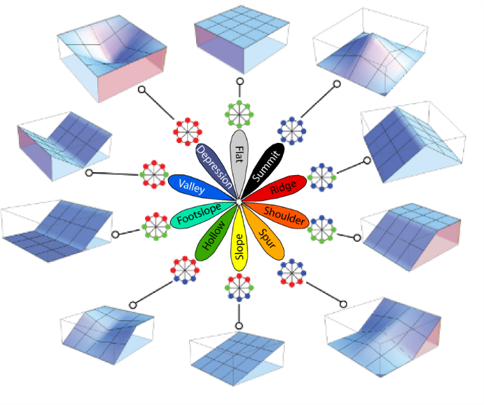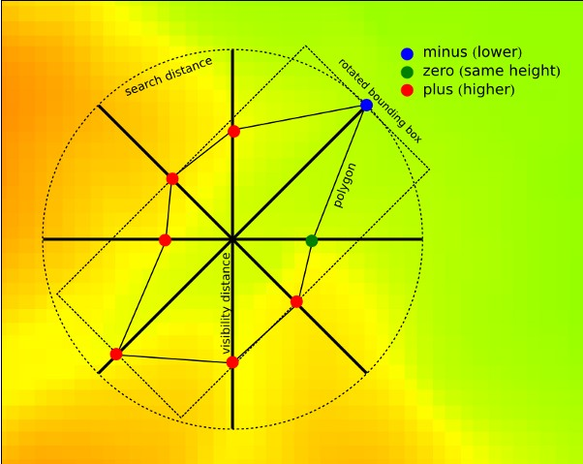
A
B
Figure 4. Visualization of the geomorphon algorithm A) Identification of the relative elevations of topography defining the viewshed of the central cell, in eight directions. The bounding cells are determined either by the line-of-sight principle, or by the search distance if no constraining topography is encountered before the search distance is reached. This feature allows the algorithm to self-adjust to the scale of the local topography. B) The ten common geomorphic forms resulting from the geomorphon algorithm with their unique arrangement of relative cell elevations. Modified from Jasiewicz and Stepinski (2013).
We first addressed the smaller end of the mapping scale through DEM smoothing. As a preprocessing step to the geomorphon analysis, the 2m resolution topobathymetric DEMs were smoothed with a non-linear, edge preserving filter (Perona and Malik, 1990; as implemented in the GeoNet software package; Sangireddy et al., 2016; Passalacqua et al., 2010) to remove small-scale topographic variation. This variation is likely a combination of noise in the elevation data (for example from vegetation interference) and real topographic roughness at a scale finer than the scale of interest (i.e., at the hydraulic unit scale). The Perona-Malik filter is suitable for geomorphic feature detection because it preserves the location and sharpness of edges, such as riverbanks, while smoothing noise between boundaries (Passalacqua et al., 2010). As an additional constraint on the minimum HGU mapping scale, we employed the “skip distance” parameter of the geomorphon tool, an inner search radius that limits the effect of noise within the DEM at a scale smaller than parameter value. We experimented with parameter values ranging from 0m to 50m (in conjunction with varying other parameters described below) and settled on a value of 10m based on inspection of the results and the expected HGU spatial scale ranges described previously.
An additional parameter for the geomorphon algorithm sets the maximum radius searched for the pixels defining the line-of-sight from each cell (Fig. 4). To correctly identify landform boundaries, this value must be larger than the scale of the largest units of interest. The scale adaptability of the geomorphon algorithm allows it to detect features smaller than the search distance (Fig. 4; Jasiewicz and Stepinski, 2013), allowing one to use a larger value without diluting the signature of smaller features. However, larger search distances increase computation time and excessively large values are problematic in several instances. For example, if the search window was large enough to see both valley walls, the entire valley bottom would be mapped as a valley geomorphon and the topographic diversity and complexity defining landforms at the scale of HGUs would not be differentiated. Likewise, if the search window was large enough to see both channel banks from the middle of the channel, the entire channel bed would be mapped as valley geomorphon and miss convex (e.g., mid-channel bar or dune crest) or plane bed features. Therefore, we experimented with search distance values larger than the upper end of the HGU length scale (~100m) but smaller than the average main channel bankfull width (~500m). Based on results from the range of parameter values from a number of UMRS navigation pools, we determined a setting of 200m for the outer search distance parameter. Finally, the flatness threshold parameter determines the minimum angle measured from a pixel to its line-of-sight bounding topography that is considered significantly different from flat. We experimented with values ranging from 0.1 to 2 degrees and determined 0.5 degrees produced the best results. Final parameter settings for the geomorphon analysis are summarized in Table 3.
The geomorphon output was a raster format with the same resolution as the input DEM (2m). To further characterize the resulting landforms, we needed individual features representing each distinct landform. We used the Raster to Polygon tool in ArcGIS Pro 3.0 (ESRI, 2022) to convert the raster to polygon features. We eliminated any very small resulting features (<25m²) by merging them with the adjacent feature sharing the longest boundary, thus defining the minimum size of mapped units as 25m². For comparison the minimum mapping size for planform change was 1000 m² (Rogala, Fitzpatrick, and Henderson, 2020).
Table 3. Summary of geomorphon tool parameter settings to automatically generate hydrogeomorphic units.
Parameter | Definition | Values
Skip Distance | Inner search radius that limits the effect of noise | 10 meters
Maximum Radius | Defines the maximum line-of-sight from each cell | 200 meters
Flatness Threshold | Minimum angle measured from pixel to line-of-sight considered significantly different from flat | 0.5 degrees

Adding hydrogeomorphic attributes to the geomorphons
Classifications based on form alone (i.e., the raw geomorphon results) are insufficient for interpreting geomorphic processes and change. Landforms with similar appearance and geomorphometric characteristics may result from different processes (Wieczorek and Migon, 2014). Additional information is therefore necessary to associate geomorphic process and likely trajectory of change to a landform. Such information may include details about flow energy; sediment characteristics; proximity and orientation relative to mainstem and tributary channels that serve as flow and sediment sources; morphometric information; setting within a channel, floodplain or backwater; and possible forcing by anthropogenic structures. We adapted the tiered taxonomic approach of Wheaton et al. (2015), to characterize each geomorphon (which are analogous to tier 2) based on its position in the channel or floodplain (tier 1) and additional morphometric and hydrogeomorphic attributes (tier 3) derived from various systemic datasets available for the UMRS.
For the tier 1 characterization, we used the floodplain inundation model developed for the UMRS by Van Appledorn et al. (2018; 2021). The model was developed by integrating 40 years (1972-2011) of daily river gage data with a slope-detrended 4m resolution topobathymetric DEM to develop a time series of inundation depths for each DEM cell. A key component of this process was the development of a raster representing the relative height of each terrain pixel above the nearest channel centerline at low flow (Van Appledorn et al., 2018, 2021). We used the relative elevation raster to define three stage categories: first, elevations below the low-flow reference elevation were classified as the permanently inundated, low-flow channel. Next, we used the relative elevation raster to define a bankfull elevation by iteratively creating elevation surfaces at a range of heights and comparing the resulting inundated areas with aerial imagery. We defined bankfull at the elevation where water started inundating terrestrial vegetation such as trees, and where there was an inflection point apparent in the relationship between elevation and inundated area (above bankfull, on the active floodplain, the inundated area increases sharply with small increases in water surface elevation). For Navigation Pools 8 and 10, the bankfull elevation occurred at a relative elevation of 1.5m. Because the inundation model was developed with water surface elevations from 2-4 gages per navigation pool and does not explicitly incorporate hydraulic information, there was some uncertainty in the delineation of the bankfull elevation. Different bankfull values produced better results in different locations across a given navigation pool, so we selected a compromise value that attempted to minimize errors across each pool.
With the bankfull elevation defined, we classified areas between the low-flow surface and the bankfull surface as the bankfull channel, and areas above the bankfull elevation as active floodplain. The floodplain inundation model includes outputs estimating frequency, duration, timing, and magnitude of flooding. Those outputs were used to define the upper extent of the active floodplain. Areas that were never inundated over the model period were classified as inactive floodplain, or terrace, for our hydrogeomorphic classification. Many geomorphon units fell entirely within one of the four flow stage categories, but some forms extended across two or more categories (for example, permanently wetted and bankfull channel categories, or bankfull channel and active floodplain). Therefore, rather than simply assigning a category to each geomorphon feature, we computed the percentage of the unit within each stage category (Table 4).
In addition to the classification of flow stages, we used the inundation model results to characterize details of the inundation regimes of bankfull and active floodplain units. Those attributes may impact potential sensitivity to hydrogeomorphic change by determining the frequency and hydraulic conditions under which sediment is delivered. We used model outputs to compute unit average values of number of inundation events over the model period, number of years with at least one inundation event, the median duration of flood events, maximum depth of inundation, and mean number of days inundated per year (Table 4).
We used the aquatic areas level 2 and 3 datasets (De Jager et al., 2018) to further characterize the hydrologic setting of units. The datasets are derived from land cover mapping from aerial imagery collected in 2010-2011 and delineate aquatic area types in a hierarchical framework. The level 2 dataset includes channel classes, subdivided into main navigation channel, channel border, side and tertiary channels, and tributary channels; off-channel backwater classes, subdivided into contiguous and isolated backwaters; and a non-aquatic (floodplain) class. No minimum mapping area was defined for the aquatic area dataset, other than for contiguous backwater lakes, which were not delineated when smaller than 400 m². The mapped features range from 50 m² - 3.4x10⁷ m². Because of different focus, scale, and methods of mapping, our geomorphon outputs often span multiple aquatic areas classes. Therefore, as with the flow stage classes described above, we computed percent overlap of the geomorphon units with each level 2 aquatic class. Subsequently, we summarized those percentages with metrics describing each unit’s percentage in lentic (backwater) and lotic (channel) classes (Table 4.)
The level 3 aquatic areas dataset further differentiated structured and unstructured channel borders and contains numerous metrics computed for each mapped aquatic area polygon. Metrics included measures of inundation depths, extent of anthropogenic features intersecting the aquatic area, morphology, vegetation type, wind fetch, perimeter mapped as lentic and lotic areas, and measures of hydrologic connectivity for backwater areas. Many of those metrics are relevant to hydrogeomorphic change. However, because the scale of mapped aquatic areas was generally larger than the geomorphon units, we derived similar metrics for each geomorphon unit from the underlying datasets (e.g., anthropogenic structures and wind fetch) rather than computing average metrics from the aquatic area attributes themselves (described below). However, several of the metrics were appropriate to summarize by unit directly from the aquatic areas attributes, particularly the hydrologic connectivity metrics. We computed unit average values for the “percent channel,” “effective connections,” and “number of lotic outlets” metrics (Table 4). The effective connections metric is computed as the ratio of the length of the longest segment of terrestrial shoreline to the total terrestrial shoreline length. Percent channel is computed as the percentage of an aquatic area region's perimeter adjacent to polygons defined as aquatic. The number of lotic outlets from aquatic area region is a measure of adjacent polygons defined as main navigation channel, channel border, tributary channel, side channel, or tertiary side channel. Aquatic area hydrologic connectivity metrics are only applicable to aquatic areas, not floodplains, and effective connections is only applicable to lentic areas.
The taxonomic system developed by Wheaton et al. (2015) identifies a variety of morphometric characteristics that can aid in the classification and mapping of HGUs. These attributes include the surface morphology (whether features are elongated or arcuate); the longitudinal continuity of the feature (continuous or discrete); the orientation of the feature relative to the channel (longitudinal, diagonal, or transverse); the lateral position of the feature relative to stream channel (bank-attached or mid-channel for channel features; proximal or distal to the channel for floodplain features), and hydraulic forcing (flow concentration or expansion, grade control). We computed metrics associated with characteristics for the geomorphon units using adapted GUT code (Bangen et al., 2017), which implements the Wheaton et al. (2015) HGU taxonomic system. Details of the metrics and their calculation are in Table 4. We computed several metrics related to planform-view surface morphology, including the area, perimeter, width, length, length to width ratio, elongation ratio, roundness, convexity, and compactness. We also computed metrics related to the three-dimensional morphology, including vertical relief and several normalized relief measures (vertical compactness, platyness and sphericity, which are normalized by a feature’s length, width, and surface area, respectively). We computed several more surface attributes of each unit, including the median slope and curvature (total, planform and profile). Curvature may help distinguish hydraulic forcing of a unit, since it impacts the acceleration and deceleration of flow. Positive values of profile curvature (which is measured parallel to slope) indicate flow deceleration, whereas negative values promote flow acceleration. Positive values of planform curvature (measured perpendicular to slope) indicate a tendency to flow to diverge, whereas negative values indicate a tendency for flow convergence. We measured the orientation of each unit (computed as the long axis of the minimum bounding geometry) relative to the orientation of the nearest channel centerline. All channels identified in the aquatic area dataset (Theiling et al., 2000; De Jager et al., 2018) were included in this computation. To measure floodplain unit position relative to the channel, we computed the median Euclidean distance to the nearest channel (again defined by the aquatic area channel classes). We also computed the range in Euclidean distance values for each unit to assess whether the unit was located entirely proximal or distal to the channel (i.e., has a low range) or whether it spans from proximal to distal, as might for example, a flood chute.
The UMRS is a highly modified river system in which artificial structures such as wing dikes, chevrons, bendway weirs and artificial levees impact hydraulics and sediment delivery within the channel-floodplain system. To determine whether mapped geomorphon units were associated with artificial structures, we overlaid the geomorphon results with the river training structure dataset from the U.S. Army Corps of Engineers Inland Electronic Navigation Chart (U.S. Army Corps of Engineers, 2011, 2013). Mapped units may be associated with artificial structures either by being part of the structure itself, or by being impacted by hydraulic forcing caused by the structure, which may result in sediment deposition or scour. Therefore, we computed metrics to quantify direct overlap (length of artificial structures overlapping a unit, number of structures overlapping the unit, and length of artificial structures overlapping the unit, normalized by the unit’s area) as well as proximity to artificial structures (percentage of the unit overlapping a 10m buffer around artificial structures).
One important driver of hydrogeomorphic change in the UMRS, and one of concern for river managers, is wave-driven erosion of shorelines, islands, and relict land surfaces left above increased water levels following the closure of the lock and dam system (WEST Consultants, Inc., 2000; Rogala, Fitzpatrick, and Henderson, 2020). The higher water levels in impounded areas increased wind fetch and increased the potential for larger, more erosive waves. To estimate susceptibility of mapped units to this mechanism of hydrogeomorphic change, we used the output from a wind fetch model (Rohweder and Rogala, 2020). The model was developed for aquatic areas identified from the 2010/2011 landcover mapping dataset and determined wind fetch values based on length of open water uninterrupted by land, weighted by wind direction measurements between 2010 and 2019. For mapped units that intersected the wind fetch modeling domain (i.e., aquatic areas) we computed the median weighted wind fetch value for the unit.
As noted previously, the sequential lock and dam structures within the system impart a longitudinal gradient in sediment availability and transport capacity that may create hydrogeomorphic process zones defined by the relative impacts to those two fundamental hydrogeomorphic drivers (Fitzpatrick et al., 2022; Skalak et al., 2013). To account for the importance of longitudinal position, we computed each HGU’s median river mile from a raster dataset interpolated laterally across the valley bottom from the navigation channel river mile measures. To locate each feature’s relative longitudinal position within its navigation pool, we calculated a normalized river mile metric, which is the percentage distance between the upstream and downstream lock and dam structures. A value of zero for the normalized river mile reflects a unit immediately downstream of a lock and dam, whereas a value of 100 represents a unit immediately upstream of a lock and dam. To quantify the proximity of each HGU to potential flow and sediment sources, we used the results of the sediment source-to-sink flowpath mapping analysis (described in detail below). From the least-cost path distance raster, we calculated each HGU’s median least-cost path distance from the nearest potential source channel, as well as the SPARROW model-estimated annual average sediment load associated with that source.
Finally, we characterized each mapped unit’s sensitivity to depositional change by overlaying the geomorphon features with areas of mapped planform change (Rohweder et al., 2019; Rogala, Fitzpatrick, and Henderson, 2020). The planform change dataset was developed by analyzing transitions in land cover map vegetation classes between 1989, 2000, and 2010/2011. New landforms were determined to represent enduring hydrogeomorphic change where land cover changed from aquatic classes to one of three vegetation classes: willow, wet meadow, and terrestrial vegetation. Due to resolution limitations and uncertainties associated with different water levels when the various land cover data were collected, erosional change was not quantified in the analysis, as it tends to occur over smaller spatial scales and is more easily masked by changes in water level. Areas of identified change were classified manually into four types based on hydrogeomorphic form and process, origin of sediment and proximity to existing terrestrial area (Rogala, Fitzpatrick, and Henderson, 2020; Fitzpatrick et al., 2022). Classes included tributary delta, crevasse splays, impounded deltas, bar-tail limbs, HREPS, and undifferentiated. Many smaller change polygons make up the undifferentiated group. For our mapped units, we computed the area within each feature and the percentage of the feature that experienced depositional change in either of the two periods (1989-2000 and 2000-2010/11), as well as the classified type of change.

Table 4. Hydrogeomorphic attributes computed for each geomorphon feature.
Hydro-geomorphic characteristic group | Attribute | Attribute table name | Units | Source dataset | Notes
Flow Stage | % of HGU below low flow stage | PrmWetPct | % | Floodplain inundation model (Van Appledorn et al., 2018; 2021)
 | % of HGU between low flow and bankfull stages | BKfullPct | %
 | % of HGU on active floodplain | FldplnPct | %
 | % of HGU never inundated (terrace) | NoFldPct | %
Inundation | # Inundation events | AveEvNu | # Event | Floodplain inundation model (Van Appledorn et al., 2018; 2021) | Floodplain HGUs only. Calculated as average values within each HGU. Inundation statistics are calculated over a 40-year period of record from 1972-2011
 | Median duration of inundation events | MedEventDu | # Days
 | Maximum depth of inundation events | MedMaxDep | m
 | Median day of year at which peak inundation depth occurred | MedPkDay | # Years
 | Mean # days inundated per growing season | MeanGsFd | # Days
 | Median Elevation relative to the low-flow stage | RelElMed | m
Hydrologic setting | Main navigation channel % | MNC | % | Aquatic Areas Level 2 (Theiling et al., 2000) | Calculated as % of HGU that is within each aquatic setting
 | Channel border % | CB | %
 | Side channel % | SC | %
 | Tertiary Channel % | TSC | %
 | Tributary Channel % | TRC | %
 | Contiguous floodplain lake % | CFL | %
 | Isolated floodplain lake % | IFL | %
 | Non-aquatic % | N | %
 | Lentic area % | LentPct | % |  | Sum of lentic areas
 | Lotic area % | LotPct | % |  | Sum of lotic areas
Hydrologic connectivity | Percent channel | pct_chan | % | Aquatic Areas Level 3 (Theiling et al., 2000; De Jager et al., 2018) | See AQA level 3 documentation for details
 | Effective connections | econ | -
 | # Lotic outlets | num_outl | -
Morphometry | Morphologic form | Form | - | Geomorphons | Simplified grouping of geomorphons defining whether a unit is convex (1), planar sloping (2), planar flat (3), or concave (4)
 | Area | Area_m2 | m^2 | Geomorphons
 | Perimeter | Perimeter | m | Geomorphons
 | Width | Width | m | Geomorphons
 | Length | Length | m | Geomorphons
 | Length to width ratio | LtoWRatio | - | Geomorphons | Length/Width
 | Elongation Ratio | ElongRatio | - | Geomorphons | $$\frac{2⋅\sqrt{Area/π}}{Length}$$
 | Categorized elongation | Morphology | - | Geomorphons | ER < 0.6 = Elongated
 | Roundness (plan view) | Roundness | - | Geomorphons | $$\frac{Area}{{\left(Convex Hull Length\right)}^{2}}$$
 | Convexity (plan view) | Convexity | - | Geomorphons | $$\frac{Convex Hull Length}{Perimeter}$$
 | Compactness | Compactnes | - | Geomorphons | $$\frac{4⋅π⋅Area}{{\left(Perimeter\right)}^{2}}$$
 | Relief | Relief | m | Topobathy DEM (USACE, 2016) | Max Elevation – Min Elevation
 | Vertical Compactness | VCompact | - |  | $$\frac{Relief}{Length}$$
 | Platyness | Platyness | - |  | $$\frac{Relief}{Width}$$
 | Sphericity | Sphericity | - |  | $$\frac{Width⋅Relief}{Length^{\frac{2}{3}}}$$
 | Slope | SlopeDeg | Degrees | Topobathy DEM (USACE, 2016) | Median value for unit
 | Total curvature | Curvature | cm |  | Median value for unit
 | Planform curvature | CurvPlan | cm |  | Median value for unit
 | Profile curvature | CurvProf | cm |  | Median value for unit
 | Orientation relative to nearest channel | Orient | Degrees | Geomorphons, AQA | 0°-90°
 | Categorized orientation relative to nearest channel | OrientCat | - |  | 0-15°=Longitudinal  15-75° = Diagonal  75-90° = Transverse
 | Median Euclidean distance from nearest channel border | EucDistMed | m | AQA level 2 (Theiling et al., 2000)
 | Range of Euclidean distance from nearest channel border | EucDistRan | m
Artificial Structures | Length of artificial structures overlying HGU | len_AS | m | UMRS Navigation charts (USACE, 2011, 2013)
 | # artificial structures overlying HGU | num_AS | -
 | Length of artificial structures overlying HGU, normalized by HGU area | len_AS_m2 | m/m^2
 | Percent of HGU overlying 10m buffer around artificial structures | pct_AS10m | %
 | Percent of HGU overlying 50m buffer around artificial structures | pct_AS50m | %
Wave Erosion Potential | Median weighted wind fetch | fetw_med | m | Weighted wind fetch model (Rohweder and Rogala, 2020) | Calculated for units intersecting/adjacent to aquatic areas
Longitudinal Position and Slope | Median river mile of HGU | RivMi | Mile | UMRS river mile dataset (USACE, 2011, 2013)
 | Normalized river mile | RivMi_nrm | % |  | Calculated as percent distance downstream from a navigation pool’s upper lock/dam
 | Longitudinal profile slope from water surface elevations at the 10 percent exceedance flow | WSEslp_10 | ft/mile | UMRS stream gage data compiled for 1972-2011 by Van Appledorn et al. (2018; 2021)
 | Longitudinal profile slope from water surface elevations at the 50 percent exceedance flow | WSEslp_50 | ft/mile
 | Longitudinal profile slope from water surface elevations at the 90 percent exceedance flow | WSEslp_90 | ft/mile
HGU proximity to flow/  sediment sources | Median least cost path distance from nearest source | PathDistMe | - | SPARROW model/NHD  (Robertson and Saad, 2019)
 | Annual average sediment load of nearest source | al_ss | MT/yr
 | Mean annual streamflow of nearest source reach | Wbm_meanq | ft³/s
Planform Change | Planform change area | PlnChg_m2 | m^2 | Planform change (Rohweder, 2019; Rogala, Fitzpatrick, and Henderson, 2020)
 | % of HGU with planform change | PlnChgPct | %
 | Classified type of planform change | PlnChgTyp | -

Multivariate Clustering Analysis
Next, we explored whether distinct and meaningful groupings were apparent in the combinations of geomorphon forms and the hydrogeomorphic characteristic variables computed for them, and whether those groupings could be interpreted to define HGU classes. To identify groupings, we applied a K-means statistical multivariate clustering analysis in ArcGIS 3.0 (ESRI, 2022). K-means is an unsupervised machine learning approach that identifies statistical groupings in multivariate datasets without prior classification by minimizing within-group variance and maximizing between-group variance among variables (Lattin et al., 2003; Jain, 2010).
Cluster analysis has been used in multiple geomorphic studies to classify zones of related geomorphic process and/or form. These studies have primarily taken a longitudinal approach and define process zones within the stream network at the reach or larger scale (Khan and Fryirs, 2020, Wieczorek and Migon, 2014; Elliot and Jacobson 2006). Elliott and Jacobson (2006) note that there are two general strategies for approaching cluster analysis variable selection. The first is to apply an ordination analysis, such as principal components analysis, to a large suite of potentially relevant descriptive variables, to reduce correlated, redundant variables to factor scores. The factor scores then serve as the basis for clustering. The second approach to clustering is to explore relations among variables and reduce them using scientific judgement to those that contain the most physically relevant information. Whereas selection of variables with the second method may not have as much statistical power to define clusters, the results are more readily interpretable than multivariate factor scores that combine physical variables in complex ways (Elliott and Jacobson, 2006). Following Elliott and Jacobson, (2006), we took the approach of using geomorphic judgement to select variables to define our HGU clusters.
Prior to performing the cluster analysis, we distributed the attributed geomorphon dataset among three groups based on position relative to the channel and floodplain. Groups consisted of units within the permanently wetted channel; units on the floodplain; and units spanning the transition from the channel to the floodplain, located between the low flow water surface and the bankfull water surface. This distribution recognized the fundamental differentiation of hydrogeomorphic forms and hydraulic and sediment delivery processes associated with floodplains and channels. The inclusion of the intermediate zone allowed classification of forms that span the transition zone between those two fundamental hydrogeomorphic settings, particularly in the complex multi-thread channel and floodplain system characteristic of much of the UMRS. These three zones are hereafter referred to as low-flow channel, bankfull channel, and floodplain.
Subsets of clustering variables were selected from the entire set of calculated attributes for each of the three flow zones based on their hypothesized ability to characterize hydrogeomorphic attributes relevant to each zone. We limited the total number of variables in each analysis to increase interpretability of the results. Multiple iterations of cluster analysis were run, with different selections of variables, to find variable combinations that produced groupings of features that were interpretable as distinct HGUs. In selecting subsets of clustering variables, we avoided multiple variables that were highly correlated with each other, such as the various flood inundation measures and some of the morphometric variables (for example, the multiple measures of relief normalized in different ways). We also used the R² value computed by the clustering tool for each variable to guide variable selection. The R² metric measures the effectiveness of each variable in differentiating clusters and is calculated as (TSS - ESS) / TSS, where TSS is the total sum of squares (sum of squared deviations from the global mean for the variable) and ESS is the explained sum of squares (sum of deviations from each cluster mean). We generally kept variables with R² > 0.5 for at least one flow stage zone but made exceptions where a variable had a slightly lower R² but was nevertheless important for distinguishing a particular HGU class. For example, elongation ratio had an R² of 0.40 for the low flow channel zone analysis but was useful for uniquely identifying dune features.
The K-means clustering algorithm finds a solution for a given number of clusters but does not determine the “optimal” number of clusters. The selection of the number clusters to generate is left to the analyst. Increasing the number of clusters inherently reduces within-cluster variance and increases between-cluster variance, but at a cost of simplicity and interpretability (Lattin et al., 2003; Jain, 2010). One commonly used method for selecting cluster number is with a pseudo-F statistic, which assesses the trade-off between adequacy of a cluster solution and simplicity of the solution (Lattin et al., 2003; Jain, 2010; Khan and Fryirs, 2020). The ArcGIS multivariate clustering tool allows for selection of the optimal number of clusters based on maximizing the pseduo-F statistic. However, we found that with our dataset, the pseduo-F statistic was generally maximized with two to four clusters and then decreased linearly above four clusters. We hypothesize that this is because several of our predictor variables that were important for classifying HGUs, such as lentic percentage and artificial structure proximity, were strongly bimodal, with some features having very large values and many features having values of 0. Cluster results were thus “optimized” by splitting only on those variables. Therefore, to increase the physical meaningfulness and interpretability of the cluster results, we selected cluster numbers manually. We experimented with a range of cluster numbers and selected results with sufficient clusters to differentiate distinct HGU classes but not so many that features belonging to the same HGU class were split among multiple different clusters. To elucidate the physical meaning of the clusters by their hydrogeomorphic characteristics and thereby interpret HGU classes associated with each cluster, we analyzed boxplots of standardized predictor variable values (z-scores) for each cluster in conjunction with observations of the spatial location and relationships of the features belonging to the clusters.

Sediment source-flowpath-sink (catena) mapping
An important objective of this mapping effort was to identify groupings of HGUs that are linked by hydrogeomorphic processes (hydrogeomorphic catenae). We approached this objective by examining linkages between potential sediment sources, represented by sediment loads estimated along the mainstem and tributaries by the SPAtially Referenced Regression On Watershed attributes (SPARROW) model developed for the Upper Midwest (Robertson and Saad, 2019) and depositional features mapped by Rogala, Fitzpatrick, and Henderson (2020). SPARROW is a spatially explicit, basin-scale model that uses a hybrid statistical regression/process-based mass balance approach to extrapolate streamflow and sediment load data collected at monitoring sites to all stream reaches in the modeling domain. The Upper Midwest SPARROW model was based on the NHD-PlusV2 stream network and predicts long-term average (2000-2014) flow and sediment load for all NHD reaches (Robertson and Saad, 2019).
The NHD reach scale of the SPARROW model sediment loading estimates for the mainstem was substantially larger than the scale of HGUs we mapped in this study. The SPARROW model estimated watershed- and channel-derived sediment sources at the scale of the NHD reaches and their catchments, rather than the scale of either individual or groups of HGUs (e.g., eroding banks). Additionally, in a dynamic river system like the UMR, the NHD single-streamline representation that the SPARROW model is based on no longer aligns well with the modern main stem channel in many cases. Not all side channels were included, and tributary junctures were not aligned with the most current representation of UMR channels (USACE, 2018). Therefore, rather than thinking about sediment sources in terms of HGUs, we treated mainstem and tributary channels as potential sediment sources (with average loads as estimated by SPARROW) and examined potential flow/sediment pathways across the channel-floodplain interface to the depositional units. To address the issue of lack of alignment of the NHD/SPARROW data and modern channel locations, we generated channel centerlines from the 2010/2011 aquatic areas dataset (USACE, 2018) and performed a spatial join to add the sediment load predictions from the SPARROW model segment nearest to the centerline. At flow conditions in which large amounts of sediment would be in transport and able to access backwaters (particularly isolated ones) and floodplains, most side channels and secondary/tertiary channels are likely activated. Therefore, we included all aquatic area channel classes as potential “sources”. Because the SPARROW model domain does not include all the side channels, some sediment load values were interpolated long distances and are likely inaccurate. However, almost all tributaries are modeled, so the location and sediment load from tributary channels relative to the mainstem should be representative.
To examine potential flow/sediment pathways from tributary, mainstem, and side channels to depositional change units, we used a least-cost path method included in the Path Distance and Cost Path as Polyline tools in ArcGIS Pro 3.0 (ESRI, 2022). The Path Distance tool calculates, for each cell on an elevation raster, the least accumulative cost distance from the least-cost source (i.e., channel centerline), accounting for surface distance and horizontal and vertical cost factors, which were equally weighted. For the elevation surface, we used the hydro-enforced aerial lidar DEMs that were used to create the topobathymetric DEMs (USACE, 2007). Because the hydro-enforced datasets represent the water surface elevation at the time the data were collected (rather than the channel bed topography, as in the topobathymetric data) they provided a more realistic representation of how water flows through the channel network. From the lidar DEM, we computed a flow direction raster, which was used for the horizontal cost factor. The Cost Path as Polyline analysis used the resulting least-cost path distance raster to generate least-cost path lines between sources and destinations. We derived least-cost paths between the channel centerlines and the planform change polygons (Rogala, Fitzpatrick, Henderson, 2020). The path lines were intersected with the HGU features to identify HGUs along the transport pathway and at the end of the path. An example of HGUs linked like this are a crevasse channel (transport pathway) and crevasse splay (path destination), which would be joined by a single least cost path line. We examined the unique combinations of channel source (mainstem, side channel, or tributary) to transport pathway HGU to sediment sink HGU to determine the most common groupings of HGUs related in this way (i.e., catenae).

Sensitivity to Depositional Change Analysis
The final component of our analysis was to further explore the overlay of the planform change dataset (Rogala, Fitzpatrick, and Henderson, 2020) with the HGU dataset developed in this study. To determine whether the hydrogeomorphic information contained in the HGU dataset attributes (Table 4) were predictive of a particular HGU’s sensitivity to depositional change, we developed several random forest (RF) statistical models (Breiman, 2001). RF is a machine-learning technique based on boot-strapped classification and regression trees, which has been applied to classification and regression problems in ecology, hydrology, geomorphology, and other fields (Cutler et al., 2007; Olson & Hawkins, 2012; Vaughan et al., 2017) and often outperforms other methods (Cutler et al., 2007; Olson & Hawkins, 2012).
Unlike the K-means cluster analysis, RF is a supervised machine-learning technique. The algorithm requires a training dataset with known values of the response variable of interest, which can be either a continuous variable (regression) or a categorical variable (classification). We developed two RF models: a regression model with the percent area of planform change in each HGU as the response variable, and a classification model with assigned type of planform change (Rogala, Fitzpatrick, and Henderson, 2020) as the response variable. In each model, we used a subset of the hydrogeomorphic attributes for the HGUs as predictor variables. With this analysis we investigated whether the hydrogeomorphic attributes we computed were predictive of sensitivity to hydrogeomorphic change (first model) and the process associated with that change (second model). Note, however, that RF models do not allow formal hypothesis testing regarding the significance of each predictor.
We used the randomForest package (Liaw & Wiener, 2002) in the R statistical computing software (R Core Team, 2015) to perform these analyses. We used the default of 500 classification or regression trees to construct each model as well as default values for the size of the predictor variable set available at each tree partition: p^{1/2} for the classification model and p/3 for the regression model, where p is the total number of predictor variables in the model. We used an iterative variable selection approach to eliminate uninformative predictor variables and to create parsimonious models (Olson & Hawkins, 2012; Vaughan et al., 2017). Variable importance plots were used to eliminate the least important variables from each model, proceeding sequentially until removing a variable resulted in a decline in model performance of greater than 1 percent of explained variance. Variable importance plots show the degree to which a model’s prediction accuracy decreases when each individual predictor variable is excluded from the model. A smaller decrease in accuracy indicates a less important variable. Once variable elimination was completed, we generated partial dependence plots for predictor variables remaining in the final models to graphically assess the dependence of the response variables on these important predictor variables.

Results

Hydrogeomorphic Unit (HGU) Mapping
The geomorphon analysis resulted in a seamless map of geomorphon polygons in the valley bottom, spanning the channel and floodplain (Fig. 5). Based on visual inspection of the resulting features, the selected parameter values of 10m inner search window, 200m outer search window, and 0.5-degree flatness threshold, combined with the DEM filtering step, produced features at the appropriate length scale for defining HGUs. In Navigation Pool 10, 243,495 individual features were identified, ranging in size from 25 m² to 1,288,689 m² and encompassing all ten possible geomorphon types. The largest features identified exceeded the length scale of the 200m search window substantially and resulted from the aggregation process of converting the raw raster output to polygon features. These features were primarily long, continuous channel side slopes and thalwegs and featureless, flat backwater bottoms. Even without the additional hydrogeomorphic information computed for each geomorphon, multiple HGUs can be visually identified from the results. A non-exhaustive list (highlighted in Fig. 5) includes A) scroll ridge and swale and point bar; B) channel thalweg and side slopes; C) dunes; and D) backwater flat.
Results from the multivariate clustering analysis showed promise for automated classification of the geomorphon features based on the additional hydrogeomorphic attributes. Through experimentation with different numbers of clusters within each flow stage zone (low-flow channel, bankfull channel, and floodplain), we selected solutions with 8, 10, and 8 clusters, respectively. Solutions with fewer clusters tended to group unlike units together, whereas solutions with more clusters produced clusters that were difficult to assign physical meaning and results that were difficult to interpret. By analysis of hydrogeomorphic variable ranges for each cluster (Fig. 6-8), along with observations of the spatial location and relationships of the features belonging to the clusters (e.g., Fig. 9), we identified physically meaningful HGU associations for most clusters. See Table 6 for descriptions of the defining characteristics of each cluster and our interpretations of their HGU associations. Note that the cluster numbers are arbitrary and simply represent the random order of seed features selected at the start of the cluster algorithm. Data described here are available in Vaughan et al. (2025).
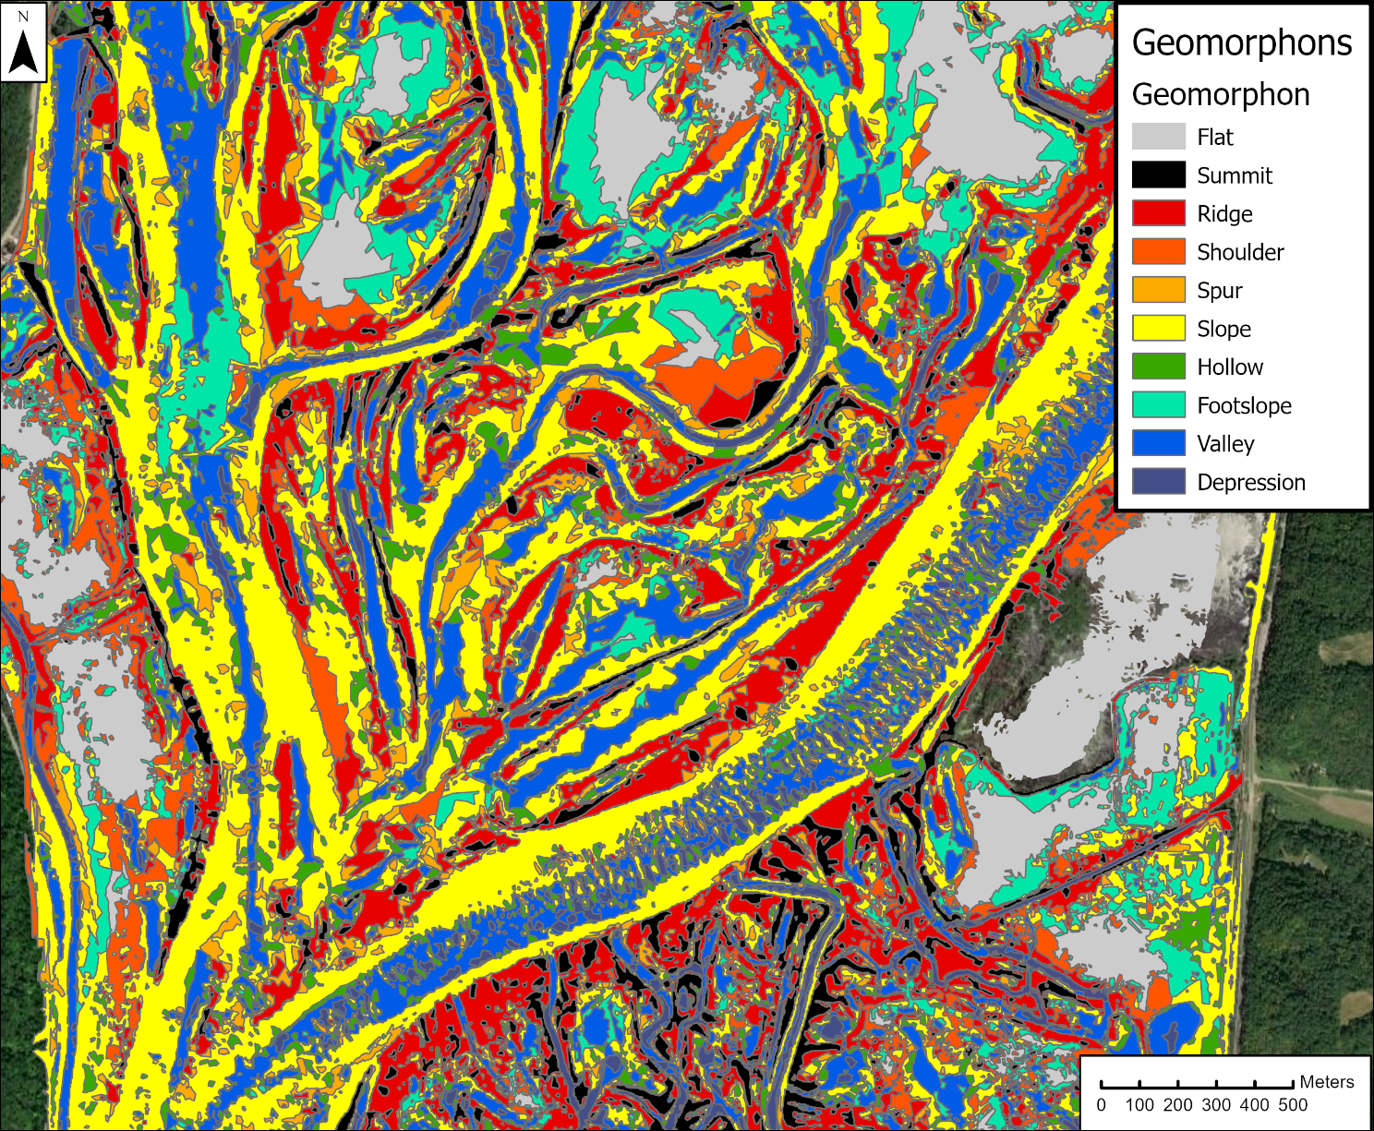
A
C
B
D
Figure 5. Geomorphons for an example segment of Navigation Pool 10. HGUs are apparent from visual inspection, including, A) scroll ridge and swale and point bar; B) channel thalweg and side slopes; C) dunes; D) backwater flat.
For all three groups, clustering variable selection resulted in the use of morphometric variables, including the unit form, mean curvature, elongation ratio, orientation relative to the nearest channel, platyness (a normalized relief value), and topographic slope (refer back to Table 4 for more information on these variables). For the low-flow channel and bankfull channel groups, proximity to channel training structures and artificial levees (percent of the unit overlapping a 10m buffer of artificial structure features) were included, which distinguished features associated with these anthropogenic structures. For the bankfull channel and floodplain groupings, the unit’s lentic area percentage was included to distinguish backwater units from channel and terrestrial units. For those groupings we also included the unit’s median elevation relative to the low-flow water elevation surface as a metric to quantify the vertical position on the bank or floodplain, which impacts the frequency and flow energy with which a unit is inundated. The clustering variables used for each flow stage category are summarized in Table 5, along with each variable’s R² value for each analysis.
Table 5. Multivariate clustering variable effectiveness (R²) for each flow stage zone clustering analysis. [HGU, hydrogeomorphic unit].
Variable group (data source) | Variable | Low Flow Channel R² | Bankfull Channel R² | Floodplain R²
Morphometry (Geomorphons, Topobathy DEM) | Morphologic form | 0.79 | 0.59 | 0.74
 | Slope | 0.53 | 0.58 | 0.67
 | Orientation relative to the nearest channel | 0.59 | 0.38 | 0.41
 | Platyness (normalized relief) | 0.51 | 0.54 | 0.63
 | Curvature | 0.60 | 0.21 | 0.41
 | Elongation ratio | 0.40 | 0.28 | 0.12
HGU Position relative to channel/  sediment sources (AQA level 2; Inundation model) | Euclidean distance to nearest channel border | N/A¹ | N/A¹ | 0.55
 | Percent lentic | N/A¹ | 0.78 | 0.05
 | Relative elevation | N/A¹ | 0.32 | 0.48
Artificial Structures (USACE UMRS Navigation charts) | % of HGU within 10m buffer around artificial structures | 0.89 | 0.90 | N/A¹
¹Variable not used for this zone’s clustering analysis.
For the two channel flow zones (low-flow and bankfull), overlap with artificial structures was highly effective at clustering (R² 0.89-0.90), identifying features composed of channel training structures and artificial levees. The morphologic form of the geomorphon (convex, concave, planar flat or planar sloping), and to a lesser degree slope and platyness (normalized relief), were important for clustering across all flow zones, with (R² values ranging from 0.59-0.79, 0.53-0.67, and 0.51-0.63, respectively). The lentic percentage was important for the bankfull channel cluster solution (R² 0.78), identifying several distinct clusters associated with contiguous backwater lakes. Orientation relative to the nearest channel was most effective at clustering in the low-flow channel zone (R² 0.59), as it readily distinguished between dune crest and trough features transverse to channels and channel thalwegs that are oriented streamwise. Elongation ratio was likewise most effective in the low-flow channel cluster solution, distinguishing elongated dune and thalweg features from less-elongated bar and pool features. The Euclidean distance from the channel border and relative elevation above the low-flow water surface were relatively effective (R² 0.55 and 0.48, respectively) at defining floodplain clusters, suggesting that different inundation and sediment delivery regimes associated with lateral and vertical position on the floodplain are important drivers of floodplain form-process relationships.
From the low-flow channel zone, we identified eight clusters (Fig. 6, Table 6). Clusters 1 and 5 represented dune crests and troughs, respectively, distinguished by their elongated shape, transverse orientation, and convex (crest) or concave (trough) forms. Cluster 3 features were interpreted as channel thalwegs based on their concave form and longitudinal orientation along channels. Cluster 7 (pools) was differentiated from other concave features (thalwegs and dune troughs) by their less elongated, rounder shape, although some dune troughs are apparent in cluster 7. Clusters 2 and 6 (toes of banks and bar faces) were characterized by relatively high values for slope and platyness (normalized relief) and location generally along the margins of the low-flow channel. Cluster 4 (mid-channel bars) was composed of primarily convex forms with positive curvature, orientation longitudinal to diagonal, and less elongation than the dune crests, although some dune crests are grouped into cluster 4. Cluster 8 units overlayed artificial structures and had high slope and were classified as river training structures such as wing dikes.
Features in the bankfull channel zone (area between the low flow channel and bankfull elevation) were split into ten clusters (Fig. 7, Table 6). Many contiguous backwater lakes were contained in this group, and the lentic percentage clustering variable was a strong driver of cluster formation. Six predominantly lotic clusters and four predominantly lentic clusters were formed. Of the lentic clusters, one grouping (cluster 1—sloping backwater margins) consisted of planar sloping and convex forms that were relatively elongated and occurred spatially along the edges of contiguous backwaters (Fig. 9). Clusters 4 and 5 both had concave and planar flat forms with low slope and medium relative elevation and were interpreted as contiguous backwater flats and pools. The final lentic class (cluster 6—contiguous backwater bars) was composed of concave forms with higher relative elevation compared to the other lentic classes.
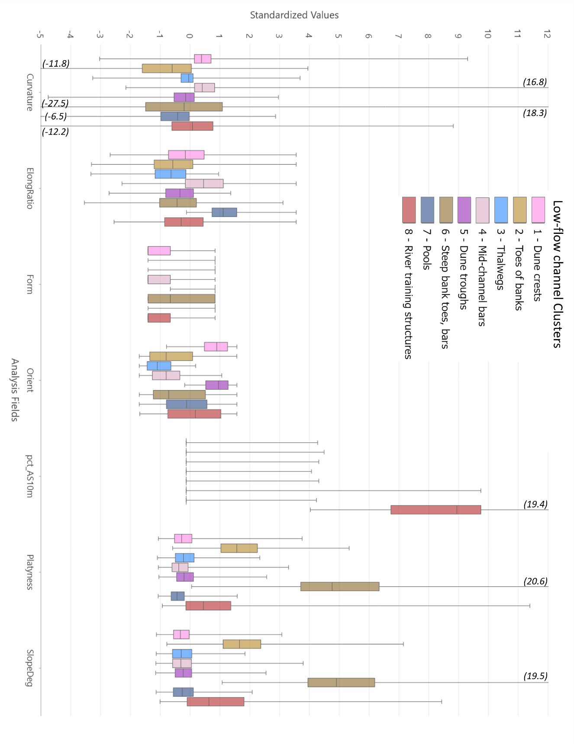
Figure 6. Boxplots showing distribution of clustering variables for low-flow channel HGUs. Plots depict the minimum, first quartile, median, third quartile, and maximum. Numbers in parentheses denote maximum value when range bar extends off the scale. Cluster numbers and colors in the legend correspond to those in Table 6 and Figure 9.
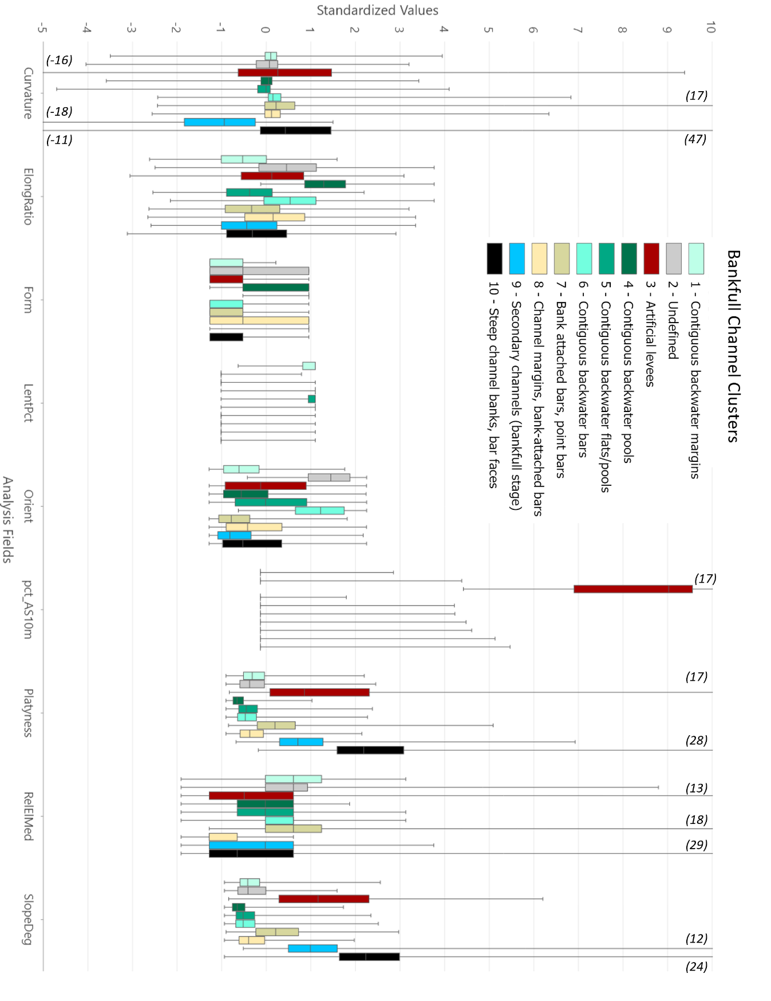
Figure 7. Boxplots showing distribution of clustering variables for bankfull channel HGUs. Plots depict the minimum, first quartile, median, third quartile, and maximum. Numbers in parentheses denote maximum value when range bar extends off the scale. Cluster numbers and colors in the legend correspond to those in Table 6 and Figure 9.
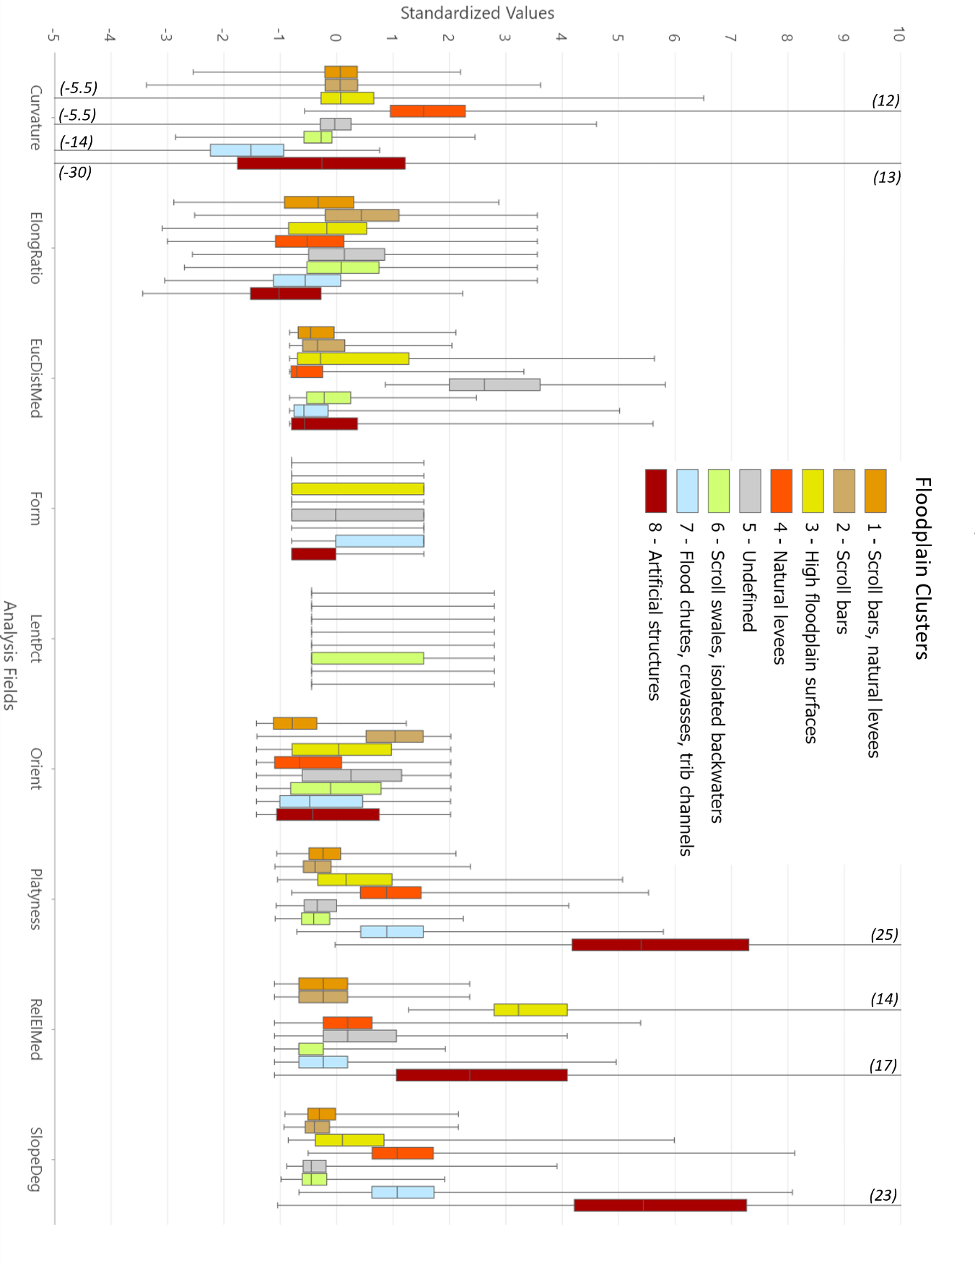
Figure 8. Boxplots showing distribution of clustering variables for floodplain HGUs. Plots depict the minimum, first quartile, median, third quartile, and maximum. Numbers in parentheses denote maximum value when range bar extends off the scale. Cluster numbers and colors in the legend correspond to those in Table 6 and Figure 9.
Table 6. Multivariate clustering results, with defining attributes of clusters and their HGU interpretation.
Setting | Cluster | Defining Attributes | HGU interpretation
Low-flow Channel | 1 | Convex forms, transverse, elongated. | Dune crests
 | 2 | Concave forms, high platyness, high slope, high curvature (positive and negative). Located along margins of low-flow channel. | Toes of banks
 | 3 | Concave forms, elongated, longitudinal or diagonal. | Thalwegs
 | 4 | Convex forms, longitudinal to diagonal, not elongated, positive curvature. | Mid-channel bars
 | 5 | Concave forms, transverse, elongated. | Dune troughs
 | 6 | All forms, high platyness, high slope. Located along margins of low-flow channel. | Steep bank toes, bar faces
 | 7 | Concave forms, negative curvature, not elongated. | Pools, dune troughs
 | 8 | High artificial structure percent, high slope and platyness. | River training structures
Bankfull Channel | 1 | Lentic; convex and slope forms, elongated, medium relative elevation, low slope. Located along edges of contiguous backwaters. | Contiguous backwater margins
 | 2 | Lotic; slope and concave forms, transverse, not elongated. | Undefined
 | 3 | Lotic; convex forms, high percent artificial structures, high slope and platyness, large curvature (pos and neg). | Artificial levees
 | 4 | Lentic; concave and flat forms; medium relative elevation, elongated, longitudinal, low slope. | Contiguous backwater flats and pools
 | 5 | Lentic; concave forms; medium relative elevation, not elongated, low slope. | Contiguous backwater flats and pools
 | 6 | Lentic; convex and slope forms, not elongated, higher relative elevation than other backwater classes, low slope. | Contiguous backwater bars
 | 7 | Lotic; convex forms, longitudinal, medium platyness, high relative elevation, medium slope. Located along channel margins. | Bank attached bars, point bars
 | 8 | Lotic; convex and slope forms, low relative elevation, low slope/platyness. Located along channel margins. | Low-angle channel side slopes
 | 9 | Lotic; concave forms, longitudinal, elongated, high platyness, negative curvature, high slope. | Secondary channels activated at bankfull stage but not low flow
 | 10 | Lotic; convex and slope forms, high platyness, high slope, longitudinal, elongated, low relative elevation. Located along channel margins. | Steep channel banks and bar faces
Floodplain | 1 | Convex forms, elongated, medium Euclidean distance, longitudinal to diagonal, moderate slope, medium elevation. | Scroll bars, natural levees
 | 2 | Convex forms, not elongated, transverse. Similar to 1, but less elongated and more transverse. | Components of scroll bars
 | 3 | All forms, high elevation, moderate slope, medium Euclidean distance. | Elevated floodplain surfaces
 | 4 | Convex forms, positive curvature, longitudinal, high platyness and slope. Channel adjacent. | Natural levees
 | 5 | All forms, Large Euclidean distance, low platyness and slope, medium elevation. | Undefined
 | 6 | Concave forms, low elevation, some are lentic. | Swales, floodplain depressions, isolated backwaters
 | 7 | Concave and slope forms, high slope and platyness, medium elevation. | Flood chutes, crevasse channels, minor tributary channels
 | 8 | High slope, platyness, curvature, and relative elevation. | Artificial structures, valley wall edges

Of the lotic bankfull channel clusters not associated with backwaters, three (7, 8, and 10) were located longitudinally along channel margins (Fig. 9) and comprised elongated, predominantly convex and planar sloped forms. Cluster 10 units (steep channel banks) had the steepest slopes and highest degree of platyness. They were frequently located on the outer bank of meander bends on the main and secondary channels (i.e., cutbanks). Cluster 7 (point bars and other bank-attached bars) had intermediate slope/platyness values (between clusters 10 and 8) and higher relative elevation than cluster 8. Cluster 8 had the lowest slope/platyness of this set of three clusters and the lowest relative elevation. They were frequently long, continuous features adjacent to the low-flow zone and often located stream-ward of a cluster 7 (bar) or cluster 10 (bank) feature (Fig. 9). We classified these as low angle channel side slopes. Cluster 3 (artificial levees) were also convex forms oriented along channel margins but were distinguished by large artificial structure overlap. Cluster 9 were concave, elongated channel forms originating from main or side channels and cutting across the floodplain (Fig. 9) and were interpreted as secondary channels activated at bankfull stage but not at lower flows. Cluster 2 did not exhibit an obvious spatial pattern or morphologic signature, and we did not assign a definitive HGU class to it.
The floodplain units were split into eight clusters (Fig. 8, Table 6). Cluster 1 contained a mix of scroll bars and natural levees. The features ranged from low to moderate on Euclidean distance to the channel, with natural levees being channel-adjacent and scroll bars more distal; however, the differences across that variable were not strong enough to result in separate clusters for those distinct HGU types. Cluster 2 was similar to, and frequently associated spatially with, cluster 1 but with features that were less elongated and more transverse oriented. They were components of scroll bar complexes, but with less well-defined scroll morphology. Cluster 4 was made up of convex forms with positive curvature but which, compared with clusters 1 and 2, had higher slope and platyness and were strongly longitudinal in orientation. They were mostly channel-adjacent and were interpreted as well-defined natural levees (i.e., more distinct features than the levees in cluster 1). Cluster 6 was also often associated spatially with clusters 1 and 2. Its features had concave form and low relative elevation and were interpreted as scroll swales and other floodplain depressions, including larger isolated floodplain lakes. Cluster 7 (flood chutes and crevasse channels) was similar to cluster 6, but with higher slope, more-elongated shape, and higher relative elevation. This cluster also contained some minor tributary channels flowing across the floodplain before joining the main channel. Cluster 8 was defined by very high values of slope, platyness, curvature, and relative elevation and contained predominantly anthropogenic structures such as roads and bridges (not river training structures) as well as valley wall edges. Clusters 3 and 5 had less easily interpreted features. Both contained a mix of all morphologic forms (convexities, concavities and planar features) with moderate to high relative elevations and distance from channels. Assigning a particular HGU class to these clusters was difficult, but they were generally high-elevation, distal floodplain features, which would be infrequently inundated and have low likelihood for hydrogeomorphic change.
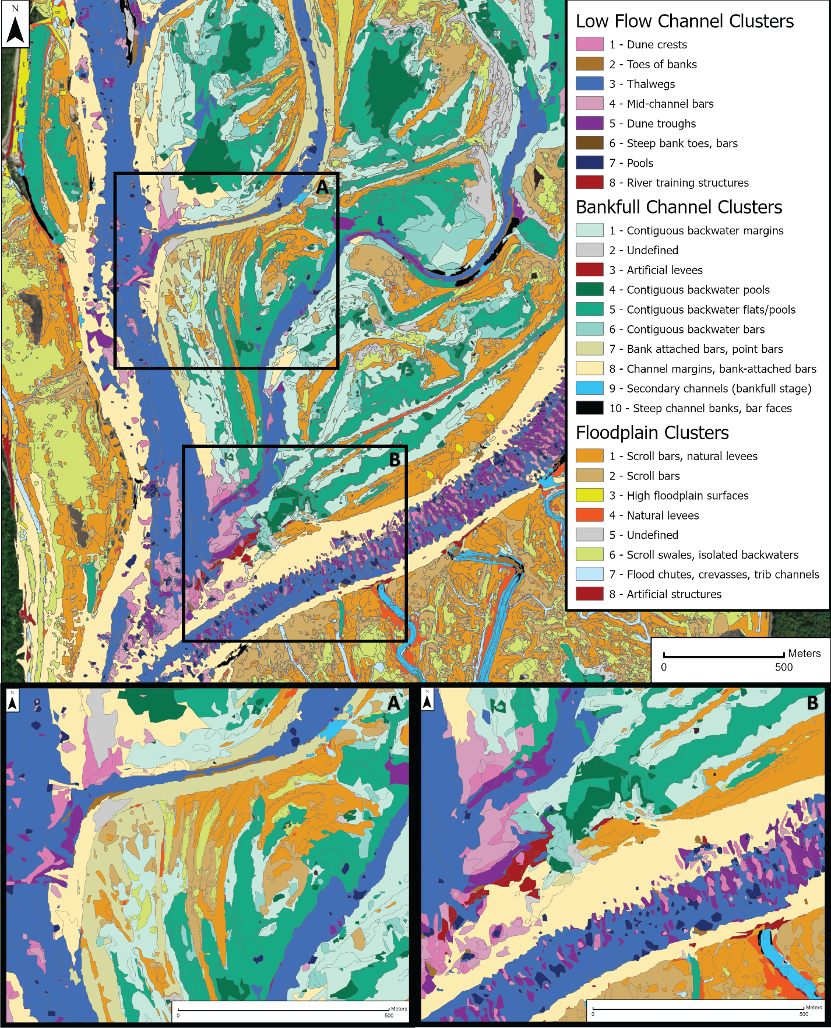
Figure 9. Multivariate clustering analysis results for a representative reach of pool 10, the same area as shown in Figure 5. Locations of inset maps shown are indicated. A) Zoomed inset showing HGU cluster results for a scroll/point bar complex. B) Zoomed inset showing main channel detail, including a dune field, river training structure, mid-channel bars, and levees.

Sediment source-flowpath-sink (catena) mapping
Least-cost flow paths were mapped from potential sediment sources (defined as the main channel, side/secondary channels, and tributary channels) to sinks (Fig. 10). Across all of Navigation Pool 10, 414 paths originated from the main channel, 2,678 originated from side/secondary channels, and 229 originated from tributary channels. For each least-cost path, the HGU cluster containing the longest length of the path (i.e., largest overlap) was recorded, as was the HGU at which the path terminates. The former may represent zones of convergent flow, sediment transport and potential erosion during high flow events, while the latter represent the depositional HGUs identified by repeat land cover comparisons (Rohweder, 2019; Rogala, Fitzpatrick, and Henderson, 2020). For each source channel type, there were 3-4 dominant combinations of transport to depositional HGU that were much more prevalent than others (Figs. 11 – 13). Throughout this section, transport and depositional HGUs are referred to by their cluster number with flow zone abbreviated: low-flow channel (LFC), bankfull channel (BFC), or floodplain (FP). Data are available in Vaughan et al. (2025).
The most common groupings of transport HGU depositional change HGU originating from the main channel were associated with the scroll and point bar complex catena (Table 2; Fig. 10A). These paths had transport HGUs of low-angle channel side slopes (BFC8), scroll bars and natural levees (FP1), and scroll swales (FP6). Depositional HGUs included low-angle channel side slopes (BFC8), scroll bars (FP1 and FP2), scroll swales (FP6), and point bars and other bank-attached bars (BFC7) (Fig. 11). Other less common main channel linkages included channel side slopes (BFC8) backwater flats/pools (BFC5) and contiguous backwater margins (BFC1). These least-cost paths originating directly from the main channel and crossing channel banks to contiguous backwaters were not intuitive, as the easiest route to contiguous backwaters would seem to be through side channel connections to the main channel. These non-intuitive path connections may indicate that the equal weighting used for the horizontal and vertical cost factors overestimated the horizontal cost associated with longer paths through side channels relative to the vertical cost of overtopping the bank in some cases. Regardless, these overbank paths identify local low areas along the channel banks and breaks in the natural levees that may direct flow and sediment to backwaters and the floodplain at higher flows. By absolute number, these direct main channel-to-contiguous backwater overbank connections were much less common than connections to backwater HGUs originating from side channels (Fig. 12).
Flow path connections originating from side and secondary channels were the most common flow paths (Fig. 12), accounting for 80% of the total paths identified in these analyses of Navigation Pool 10. This result highlights the importance of side channels for storing and delivering sediment to floodplains in the UMRS. As with paths originating in the main channel, the most common side channel paths were associated with the scroll/point bar complex catena: scroll bars and natural levees (FP1) FP1 and bank attached bars/point bars (BFC7) BFC7. Also prevalent were flow paths associated with the impounded delta catena (Table 2), with paths that originated from side channels, flowed through contiguous backwater margins or flats/pools (BFC1 and BFC5, respectively), and terminated at planform change units within the backwaters themselves (BFC1 and BFC5) or at scroll bar complexes adjacent to the backwaters (FP1). The final common least-cost path type was associated with flow through and deposition in floodplain depressions such as scroll swales and backwaters (FP6 FP6). These paths are associated predominantly with the scroll bar complex catena (Fig. 10A), although they represent sedimentation within existing scroll swales rather than lateral migration and extension of the scroll complex.

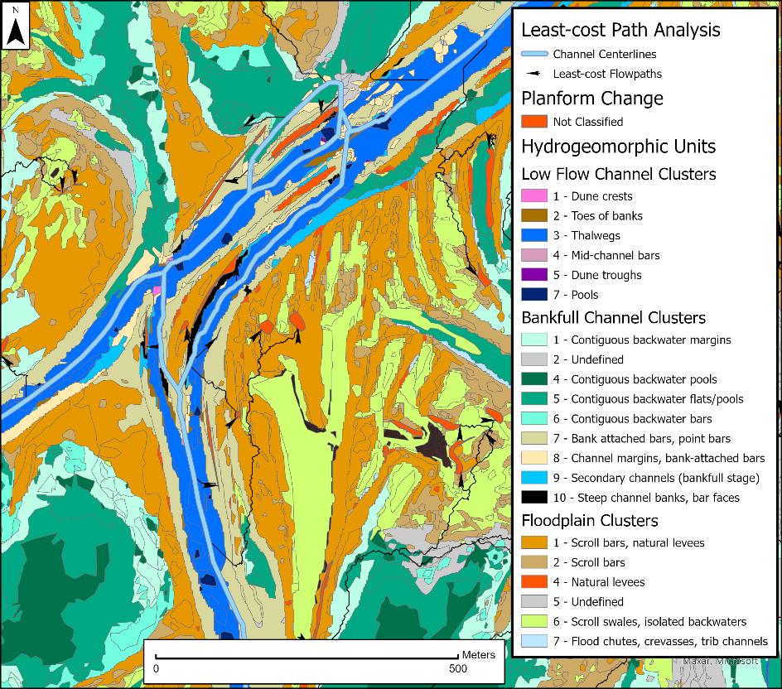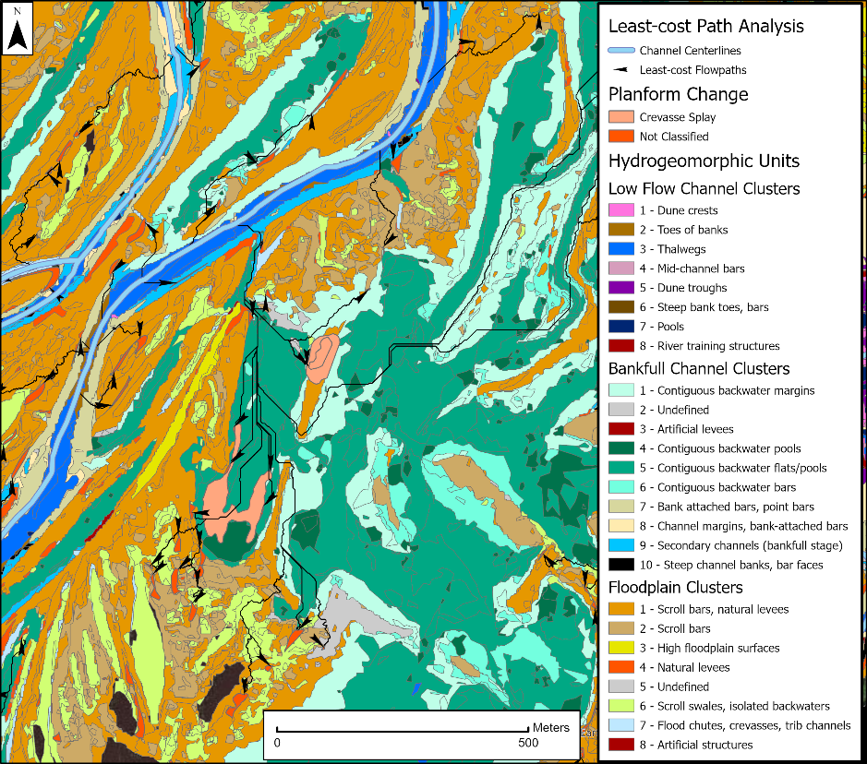
A.
B.
Figure 10. Least-cost flowpaths connecting channel centerlines to depositional planform change features in two segments of Navigation Pool 10, representing two catena types: A) Scroll bar complex. B) Crevasse channel and splay. Arrows on least-cost flowpath lines indicate direction of flow and are located at the termination of the path.
The dominant cost path grouping originating in tributary channels was associated with the HGU representing isolated backwater lakes and floodplain depressions such as scroll swales (FP6 FP6; Fig. 13). Tributary deltas often form where tributary channels enter directly to low-slope, low- velocity backwaters with insufficient transport capacity to move the supplied sediment. Other common cost path groupings from tributary channels included bank-attached bars and scroll bars (FP2 FP2; FP1 FP1; BFC7 BFC7). Some of these paths were associated with bar-tail limb development and island growth within tributary deltas where, for example, the high sediment load of the Wisconsin River enters the Mississippi. Others were associated with point bar deposition and active meandering within tributaries that enter the river valley distally to the main channel and flow across flat floodplain for a distance before entering a main or side channel. Another set of cost paths originating from tributary channels passed through flood chutes and scroll swale HGUs (FP6) and terminated at scroll bar/natural levee HGUs (FP1). These paths may represent deposition under high flow conditions, during which the tributary stage reached the elevation of the flood chutes/scroll swales and transports sediment onto the floodplain.
The crevasse channel and splay catena (Table 2) was identified in the hydrogeomorphic change conceptual model (Fitzpatrick et al., 2022) and planform change mapping work (Rogala et al., 2020a) as an important type of hydrogeomorphic change in the UMRS. Least-cost paths associated with that catena were not among the most common path types identified in this analysis for Pool 10 (Figs. 11-13), although we did visually identify multiple of these features. In one example, least-cost path lines originated from a side channel, flowed through a crevasse channel cut through a natural levee, and ended at crevasse delta bars in a backwater lake (Figure 10B). It is apparent from this example that our method of classifying the cost path types may have resulted in underestimation of the prevalence of this catena. We categorized the cost paths’ transport HGU type based on the longest overlap. In this example, even though the flow paths traversed an HGU classified as a crevasse channel (light blue color in the figure), they passed through a longer length of the backwater flat/pool HGU, so they were classified based on the latter HGU in that case.

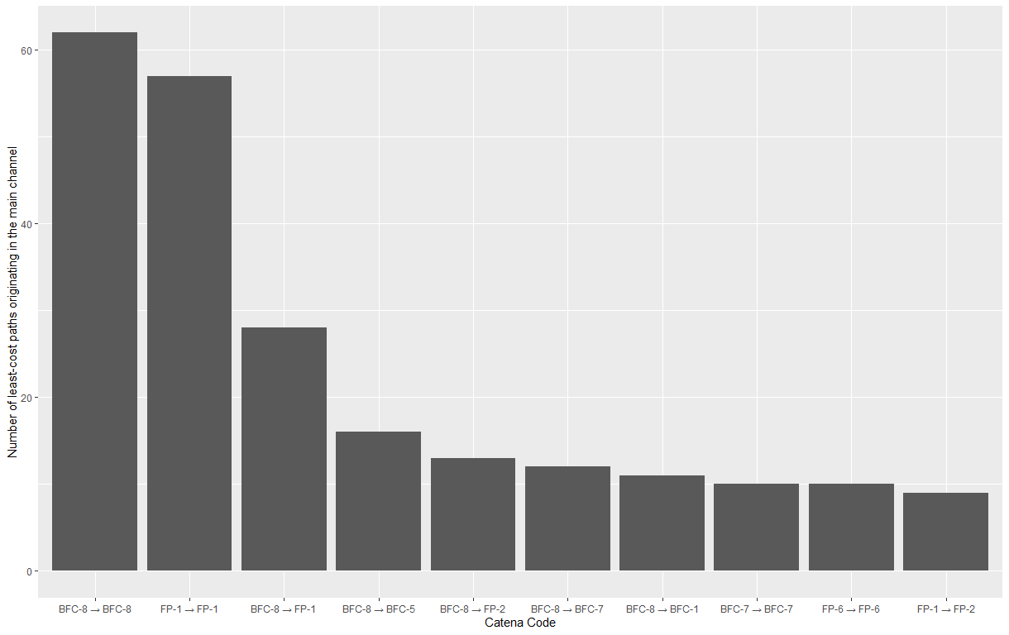
Figure 11. Counts for the 10 most common HGU least cost path overlays originating from the main channel. Codes represent the HGU cluster number overlain by the cost path. BFC = bankfull channel, FP = Floodplain.
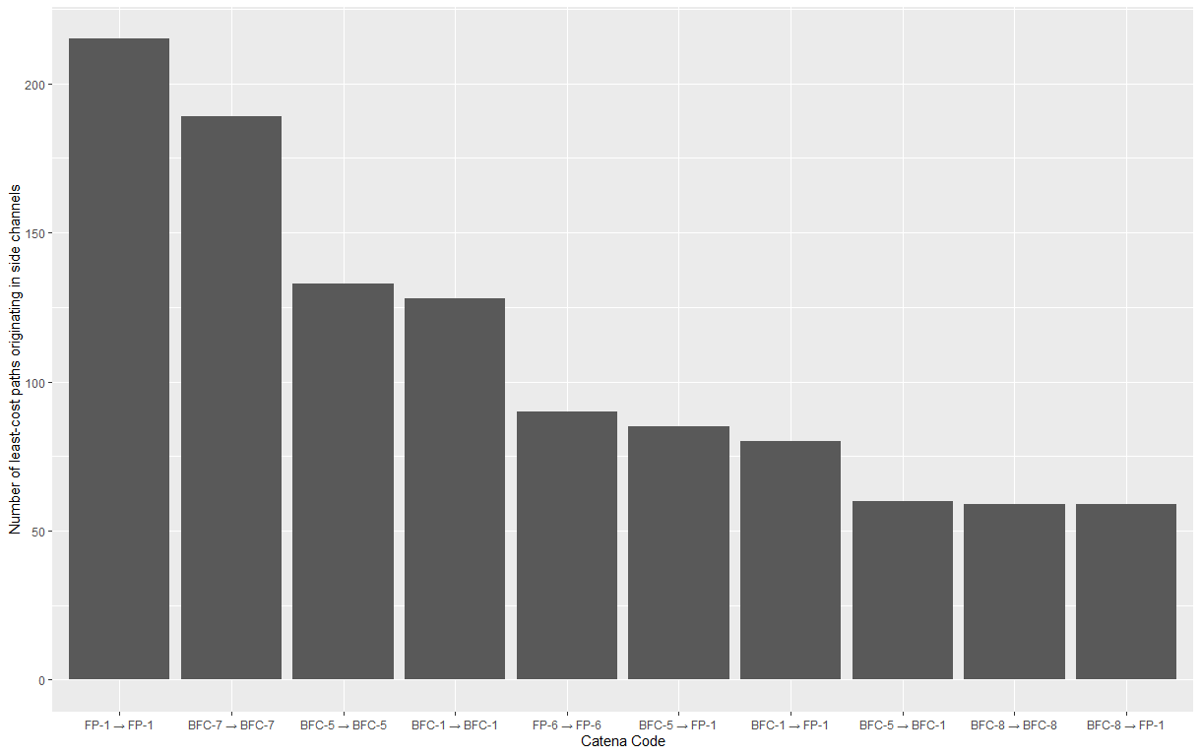
Figure 12. Counts for the 10 most common HGU least cost path overlays originating from side/secondary channels. Codes represent the HGU cluster number overlain by the cost path. BFC = bankfull channel, FP = Floodplain. Note the larger y-axis scale compared to Figures 11 and 13.

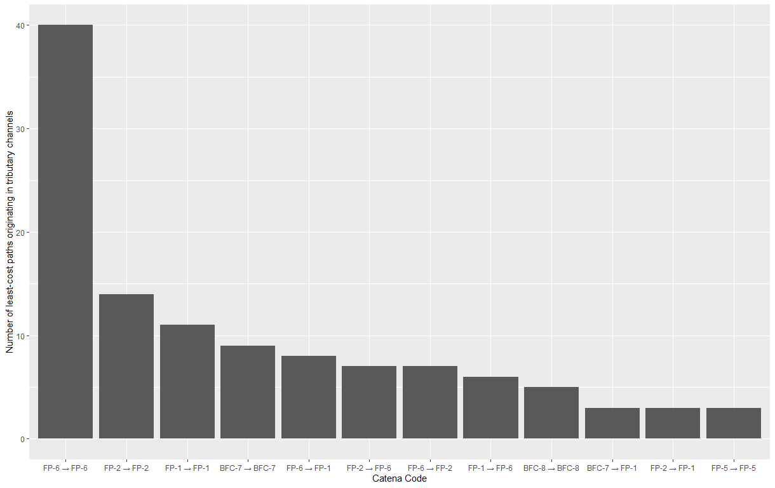
Figure 13. Counts for the 10 most common HGU least cost path overlays originating from tributary channels. Codes represent the HGU cluster number overlain by the cost path. BFC = bankfull channel, FP = Floodplain.

Sensitivity to Depositional Change Analysis
The Random Forest (RF) models revealed relationships between HGU characteristics and the location and mechanisms of depositional planform change in Navigation Pool 10. The regression RF model exploring associations between hydrogeomorphic characteristics and the location of planform change (represented by a response variable measuring the percentage of each HGU that overlapped a planform change polygon) explained 23.5 percent of the variance in the response variable and had a mean of squared residuals of 132.3. Fifteen of the predictor hydrogeomorphic variables were retained in the model after the iterative variable selection process (Fig. 15), although the two most consequential variables (normalized river mile of the HGU, representing its relative longitudinal location between the upper and lower dam; and median Euclidean distance from the nearest channel) explain most (20%) of the variance. The remaining variables include proximity (Euclidean and path distances) to a channel, the lentic area percentage, various morphometric attributes, predicted SPARROW sediment load from the nearest channel, and floodplain inundation attributes.
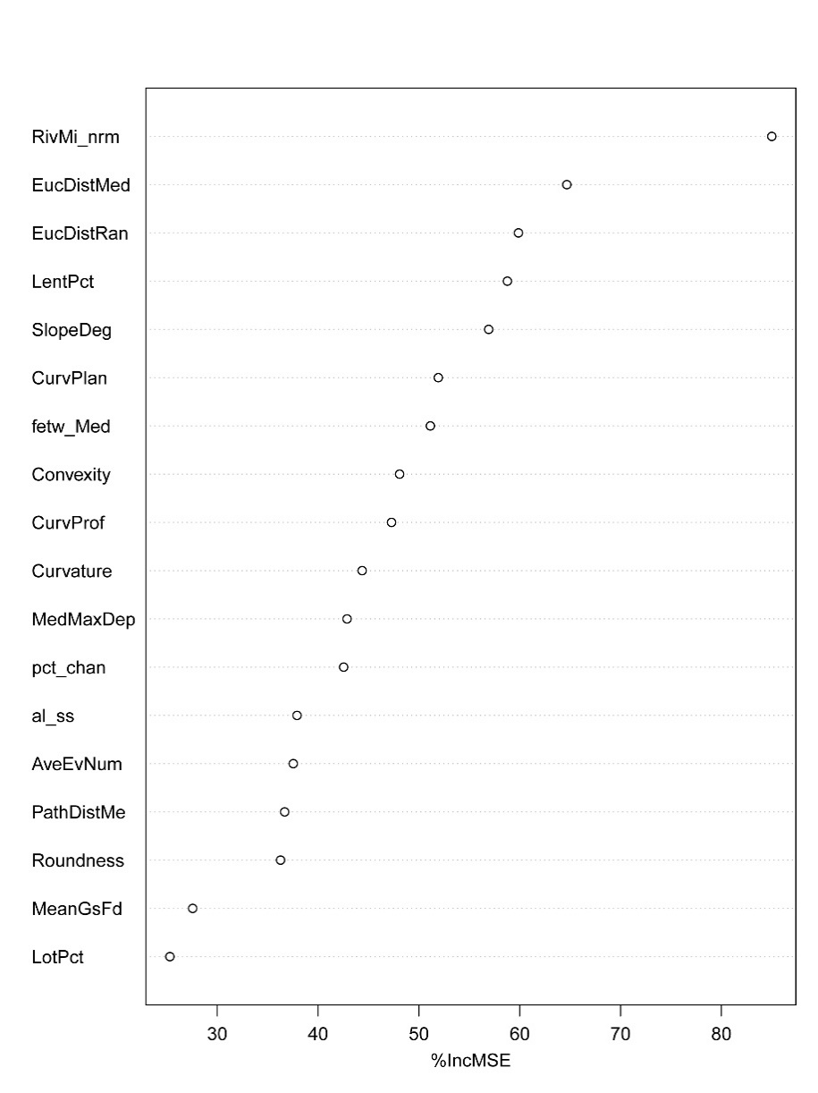

Figure 15. Variable importance for the Random Forest regression model predicting depositional planform change (represented by a response variable measuring the percentage of each HGU that overlapped a planform change polygon). X-axis shows the percentage increase in the model’s mean square error when values of the variable are permuted in the analysis.

Because of the strong dependence of the model on the normalized river mile and our interest in examining potential process zones related to the interdam sequence (Skalak et al., 2013), we assessed partial dependence for normalized river mile (Fig. 16). There is a local maximum in planform change just below the upper dam in Navigation Pool 10, caused by deposition in off-channel backwater and side channels. Depositional conditions in this zone are likely caused by reduced sediment transport capacity due to funneling of flows through the lock and dam and away from these backwater areas, combined with tributary inputs supplying sediment into these backwater areas immediately below the dam. For most of the rest of the length of the navigation pool, predicted planform change values are relatively low, with several noticeable increases associated with tributary inputs (Fig. 16). A dramatic increase in predicted planform change percentage occurs at about 80% down the length of the navigation pool (Fig. 16). This is presumably where the lower dam’s impoundment impacts begin reducing sediment transport capacity sufficiently to result in the growth of impounded delta deposits. There is a slight decrease in planform change at the very bottom of the navigation pool, which may be associated with increased wind fetch in the impoundment causing erosion and resuspension of any sediment deposited there. However, Navigation Pool 10 does not have a large impoundment like some other navigation pools do, so the effect is limited here.
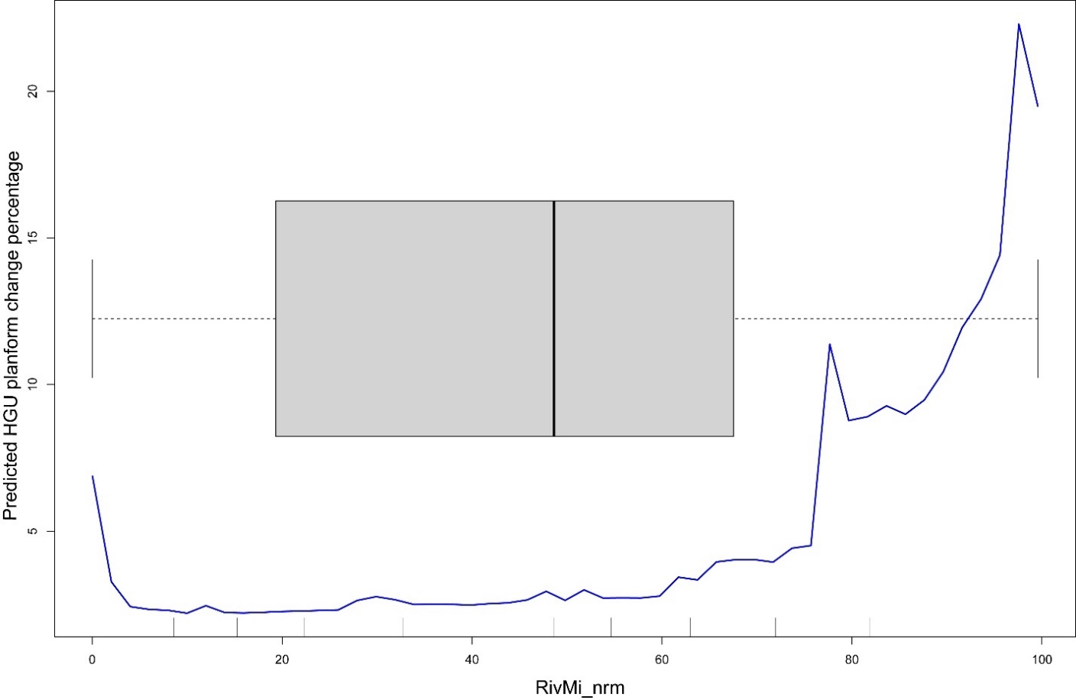 Figure 16. Partial dependence plot showing RF model’s prediction of the percentage of an HGU experiencing depositional planform change, given variation over the range of the normalized river mile variable (relative longitudinal position between dams). Box-and-whisker plot shows the distribution of values for the river mile variable within the HGU dataset used to develop the RF model.
Compared to prevalence of planform change within an HGU, the classification RF model had greater success at predicting the mechanism of planform change in an HGU from its hydrogeomorphic attributes. The out-of-bag estimate of error rate (the percentage of misclassifications of the observations withheld from bootstrapped samples used to train the model) was 12.8%. Much of the error was in the crevasse splay class (with 48.0 percent class error), for which a large percentage of observations were mis-classified as bar tail limbs (Table 7). Many HREP planform change areas were mis-classified as bar tail limbs as well. This is not surprising, however, since HREPs are constructed features which, a) likely have attributes designed to replicate natural features and, b) are not formed naturally and therefore may lack a strong relationship to the underlying hydrogeomorphic processes acting in the area where they are located. The model predicted bar tail limb and tributary delta classes successfully, with class errors of 6.5 and 11.7 percent, respectively.
Table 7. Confusion matrix for Random Forest classification of planform change types, showing the number of observations correctly and incorrectly classified, by classification type, along with the error within each class.
 | Bar Tail Limb | Crevasse Splay | HREP | Tributary Delta | Class Error (%)
Bar Tail Limb | 401 | 1 | 9 | 18 | 6.5
Crevasse Splay | 18 | 26 | 0 | 6 | 48.0
HREP | 25 | 0 | 82 | 0 | 23.4
Tributary Delta | 23 | 0 | 0 | 173 | 11.7

Nine predictor variables were retained in the classification model after the iterative variable selection process (Fig. 17). The majority of the variables were floodplain inundation metrics, including the maximum depth of inundation, mean number of days flooded during the growing season, relative elevation, average number of flood events, and number of years with a flood event over the period of record. Also included were several morphologic properties (average slope and geomorphic form) and channel proximity metrics (Euclidean distance and least-cost path distance). Note that the longitudinal position (normalized river mile) was excluded from this model, as it resulted in overfitting. Tributary delta features and HREPs were strongly associated with one or more longitudinal locations depending on the location that tributaries happened to enter the valley bottom or where HREP projects were located. Therefore, including the river mile variable resulted in perfect prediction across all classes. Because these locations were a result of localized and arbitrary circumstances rather than generalizable hydrogeomorphic patterns, we excluded the variable from the model.
Selected partial dependence analyses were conducted for the most important flood inundation variable (median maximum inundation depth for the HGU over the period of record; Fig. 18; and median least-cost path distance to the HGU; Fig. 19). Probability of all three non-HREP change classes observed in Navigation Pool 10 (bar tail limbs, crevasse splays, and tributary deltas) was low above a median maximum inundation depth of about 3m (Fig. 18), suggesting that locations with large inundation depth generally had sediment transport capacity too great for significant deposition to occur. Bar-tail limbs had a complex association with maximum flood depths, displaying several peaks and valleys over the range of 0 to 3m, indicating that these features occurred across a range of elevations on the floodplain. In contrast, tributary deltas and crevasse splays displayed strong peaks in probability around 2.5m and 2.0 m of maximum flood depth, respectively. Deposition associated with those change mechanisms may be related to hydraulic and sediment supply conditions during floods of those magnitudes. Alternatively, because maximum inundation depth is strongly correlated with floodplain elevation, those change features may have tended to occur spatially on the floodplain at elevations that happened to have those maximum inundation depths, but not be related to the inundation depth, per se.
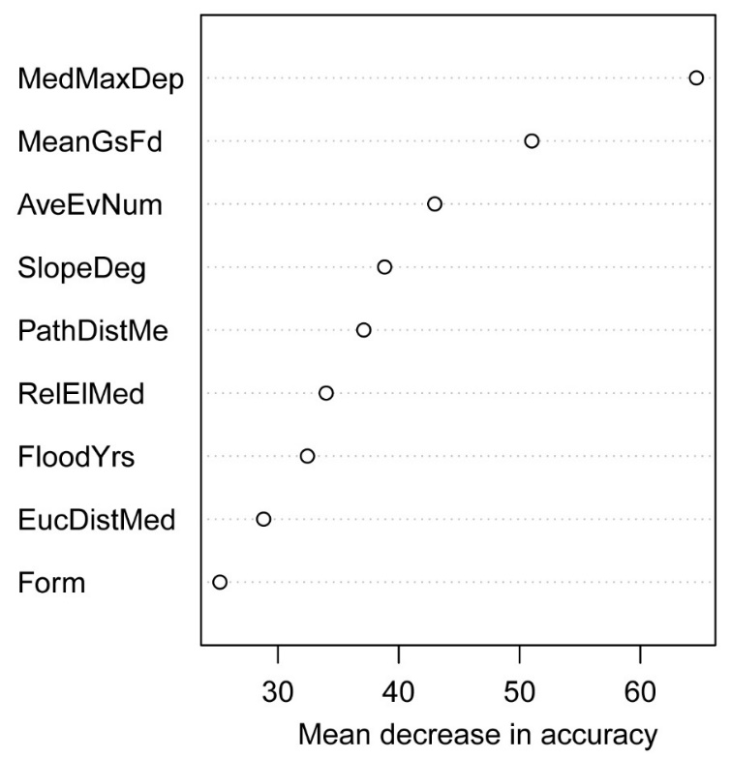

Figure 17. Variable importance for RF classification predicting type of planform change. X-axis shows the mean decrease in prediction accuracy of the model when values of the variable are permuted in the analysis.

Median least-cost path distance to a planform change feature primarily distinguished crevasse splays from bar tail limbs and tributary deltas. Bar tail limbs and tributary deltas each had peaks in probability of occurrence around cost distances of about 5000, whereas crevasse splays were most common at higher cost distances (Fig. 19). Bar tail limb and tributary delta depositional units are primarily located within the bankfull channel, and therefore have low path distance values. Crevasse splays have higher path distances associated with the high cost of getting over/through the natural levee and onto the floodplain.
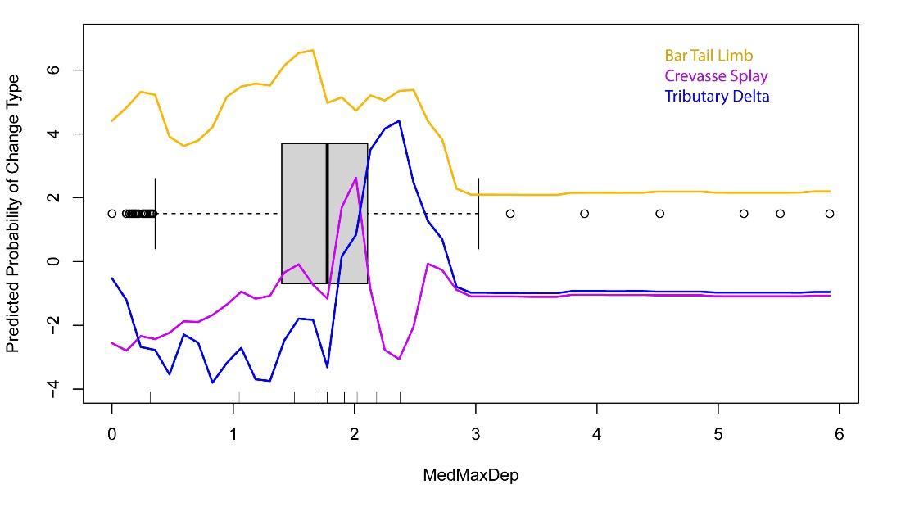
Figure 18. Partial dependance plot for median maximum depth of flooding variable, for RF classification predicting type of planform change. X-axis shows the range of values for the flood depth variable, and the Y-axis shows log-odds of class membership of each change class across the range of the predictor variable.

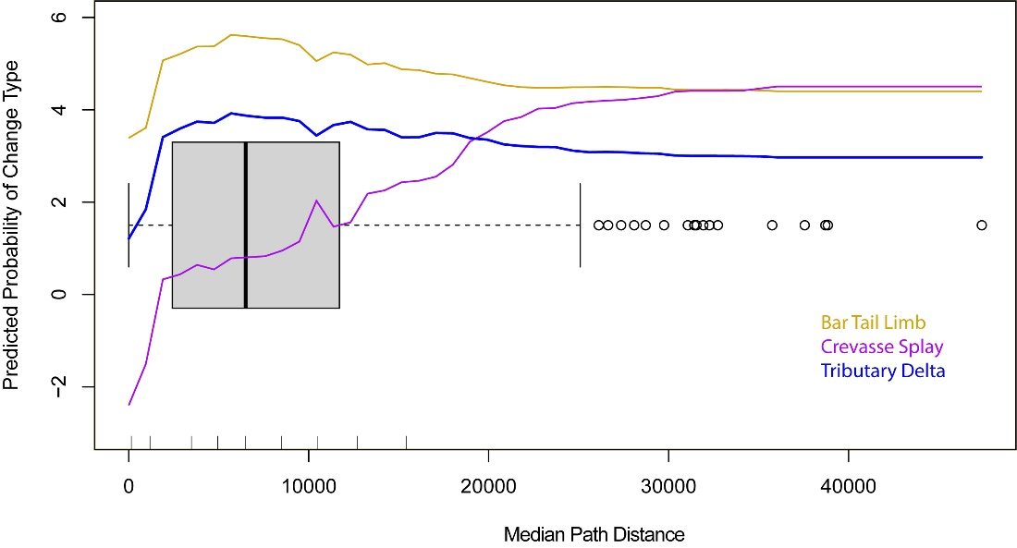
Figure 19. Partial dependance plot for median cost path distance variable, for RF classification predicting type of planform change. X-axis shows the range of values for the path distance variable, and the Y-axis shows log-odds of class membership of each change class across the range of the predictor variable.

Discussion and Conclusions

The objective of this study was to develop a method for mapping and classifying hydrogeomorphic units and process linkages between them from systemic datasets available for the UMRS, within the context of the hierarchical classification system and hydrogeomorphic change conceptual model developed as a precursor to this study (Fitzpatrick et al., 2022). In the following sections we discuss the successes and challenges encountered in applying the classification; how our results relate to previous hydrogeomorphic classification and automated mapping approaches; and next steps for expanding the classification/mapping and using it to inform management within the river system.

Automating Hydrogeomorphic Models with systemic datasets
Much of the existing geomorphic classification literature has focused on identifying stream-wise longitudinal process zones within the stream network at the reach or larger scale (e.g., Khan and Fryirs, 2020; Elliott and Jacobson, 2006). However, several automated models have been developed to map and classify landforms at the scale of geomorphic units, including the geomorphon method (Jasiewicz and Stepinski, 2013) and the Geomorphic Unit Tool (GUT; Bangen et al., 2017; Kramer et al., 2017; Wheaton et al., 2015). Each model has unique strengths and limitations with relation to its applicability to mapping HGUs in the UMRS. The geomorphon algorithm efficiently maps landforms at the HGU scale and self-adjusts to the geometry of the local terrain across the landscape, allowing landforms with different length scales to be detected simultaneously. This attribute proved to be important for mapping within the UMRS, where lengthwise river features (banks, levees, etc.) span up to several hundred or more meters, while smaller, non-contiguous features are present in the floodplain and channels. However, geomorphons are entirely form-based features, and by themselves lack information about hydrogeomorphic processes associated with them. The GUT approach to fluvial taxonomy and mapping (Bangen et al., 2017; Kramer et al., 2017; Wheaton et al., 2015) is also form-based but adds additional lines of evidence (position of an HGU within the channel or floodplain and in relation to the channel margin; detailed morphometry; orientation; and hydraulic or structural forcing elements) to classify HGUs that can be related to hydrogeomorphic processes. However, the GUT tool was developed primarily in smaller streams and is limited to the in-channel environment. Because the floodplain is an important and geomorphically active component of the UMR, inclusion of floodplain features in our mapping and classification results was necessary.
By combining components of each of these models, we were able to successfully map and identify physically meaningful HGUs spanning the channel and floodplain in the UMR. Basing our mapped units on geomorphons developed with parameter settings tuned to this large-river, floodplain-dominated environment allowed us to capture HGUs with a range of characteristic spatial scales. We adapted aspects of the taxonomic classification of HGUs developed by Wheaton et al. (2015) and embedded in the GUT tool (Bangen et al., 2017), along with additional metrics developed from systemic UMRS datasets to characterize the hydrogeomorphic setting, attributes, and change potential of the geomorphon units. By employing multivariate clustering analysis on these hydrogeomorphic attributes, we were able to identify physically meaningful and largely distinct classes of HGUs in Navigation Pool 10. The statistical clustering approach differs from the GUT method, which employs a hierarchical, decision tree approach to sort units into HGU classes based on threshold values of hydrogeomorphic attributes. The statistical approach to classification allows for flexibility in the classification by assigning class membership based on the underlying variable distributions, rather than on pre-defined threshold values. This is useful because the distributions of attribute values associated with particular HGUs are likely different in the large, floodplain river UMRS setting than in the smaller rivers for which the GUT threshold values were calibrated. Additionally, these attribute ranges may vary across the large spatial span and different geologic, climatic, and hydrogeomorphic settings within the UMRS. Flexibility in the ranges defining HGUs will account for that variability.
However, the unsupervised clustering approach had some limitations. Because clusters were not defined upfront, several of the resulting clusters contained more than one potential HGU type, while several others were not interpretable as corresponding to an HGU in Table 1. Clusters containing more than one possible HGU complicate interpretation of hydrogeomorphic process relationships associated with them. For example, bankfull channel cluster 8 contains both channel side slopes, bank-attached bars and point bars, the bars being more likely to undergo active hydrogeomorphic change than the side slopes. However, in this case the planform change data, which were not included explicitly in the clustering analysis, help distinguish between active and less-active features.
To expand the GIS analysis across the entire UMRS, we used as inputs for these models systemic datasets such as topobathy, floodplain inundation, aquatic area classifications, and planform change. The UMRS topobathy is one of the only comprehensive large river elevation datasets available and enables this systemwide mapping effort. However, there are limitations to this dataset and to using it in tandem with the other systemic datasets. The data used to develop the UMRS topobathy were surveyed over a large and variable timeframe, so it doesn’t represent a consistent point-in-time elevation surface, either within a particular navigation pool or across the system. For example, for Navigation Pool 10, the terrestrial topography data were collected during 2007, whereas the bathymetry data were collected between 1996-1999 and in 2010. The aquatic areas dataset is derived from aerial imagery collected during 2010-2011, and the planform change was mapped over two periods, 1989-2000 and 2000-2010/11. Therefore, some caution is needed when interpreting the relationship between the topobathymetric elevation data and the planform change data, in particular. Depending on when the elevation data were collected at a particular location, and the period during which planform change was observed, the HGU (and its associated metrics) mapped from the elevation data may correspond to conditions before, after, or while the change occurred. The variability in those relationships may explain some of the low explanatory power of the RF models we developed to explore relationships between HGU characteristics and sensitivity to change.

Defining map units and connecting form-process linkages
Initially, we stratified the cluster analysis by two hydrologic zones: floodplain and channel. This approach was consistent with previous studies that have drawn a boundary at the bank top, usually assuming the bank top represented a field indicator of the bankfull or channel forming flow with an annual peak flood recurrence interval of roughly 1-3 years. Obtaining interpretable results from the two-zone analysis proved difficult because many units in the ‘transition’ zone extended across the boundary defined by the bankfull elevation and did not neatly fit in either zone. Therefore, we stratified the final cluster analysis by three zones: the perennial low flow channel, the floodplain, and the transition zone spanning the low flow channel to the top of the bank. Adding the intermediate group allowed for better classification of forms found in the complex transition zone, such as bar and bank features, that were poorly represented in the two-zone model because they are adjacent to, or spanning, a boundary. It also helped identify many of the below-floodplain elevation features existing in a complex system of channels, depressions, flats, and bars.
The least-cost path analysis linked transport and depositional HGUs on the bank and floodplain into catenae based on potential common channel sources of flow and sediment. The approach offers promise for developing similar connections within additional UMRS reaches in an objective fashion. An important result of the least-cost path HGU overlay analyses is that a significant portion of the planform change units are associated with scroll/point bar complexes. Those change polygons are primarily relatively small and were left undifferentiated in the manual mapping work done for that dataset. The HGU overlay and cost path results offer a possible approach to classifying the hydrogeomorphic process/setting associated with these areas. Incorporating sediment load information explicitly in the analysis was complicated by the different temporal range and spatial/elevation models used by the SPARROW model, the aquatic areas dataset, and the HGU mapping. SPARROW model segments did not always align perfectly with aquatic area polygons and channel HGUs, making a one-to-one crosswalk between the datasets impossible in some instances. Nevertheless, the spatial scale used for the HGU mapping and the scale of data sets used for the cost-path analyses appeared to be compatible and allowed for a connection to be drawn between multiple different hydrogeomorphic forms and their potentially common origin.
An important consideration with the cost-path analysis results is that they represent hydraulic conditions at low to moderate flow. The aerial lidar from which the water surface was mapped was collected at relatively low-flow conditions and water surface slopes controlling the flow paths within channels are only strictly correct at those flows. Flow paths from the channel to the floodplain are oriented along localized paths of least resistance based on the elevation data, rather than more accurate hydraulic information. Because of these limitations, flow paths are not accurate for large floods inundating over the floodplain units. Previous studies of flow and suspended sediment records in the UMRS have shown that frequent, moderate discharges (in the range of 1.4-2.2 times the mean daily discharge) are most geomorphically effective, or responsible for transporting the most sediment over time (Benedetti, 2000). The effective discharge at McGregor, Iowa in Navigation Pool 10, has a recurrence frequency of 73 days/year and is below the bankfull discharge (Benedetti, 2000). Therefore, the flowpaths represented by our least-cost path analysis are representative of the flows that do the most geomorphic work over time and are relevant for change associated with scroll/point bar complexes, contiguous backwater sedimentation and crevasse splays. However, large, overbank floods are also geomorphically important, particularly for isolated backwater lakes and floodplain sedimentation (Belby, 2005). Two-dimensional hydraulic models could more accurately define flow paths across a range of flows including overbank flows. Such models have been developed in select areas within the UMRS (e.g., Stafne, 2012) but are not available systemwide.

Research gaps and next steps
The research gaps encountered in building the automated GIS model were primarily related to the input datasets used. As noted previously, the temporal and spatial scale of the datasets have a wide range, which makes it hard to capture a ‘snapshot’ in time of the HGUs and catenae. Future collection of elevation and aerial photography datasets that are closer in time would enable higher confidence that the multiple lines of evidence used to define HGUs and catenae are internally consistent and representative of contemporaneous, current conditions. Ideally, these datasets within a particular navigation pool would be collected within the same year, or at least close enough in time that there are no intervening large flow events that would produce large amounts of geomorphic change.
An additional gap is the lack of a geomorphic change dataset that encompasses all forms of change within the UMRS. The planform change dataset (Rogala et al., 2020) was integral for linking hydrogeomorphic process with the form-based units we mapped. However, the methods employed for generating that dataset resulted in several limitations. Because the data are based on landcover interpretation of aerial photography, it is limited to detecting change above the water surface. Only areas that underwent sufficient change to transition from aquatic cover to terrestrial, vegetated cover were identified. Aquatic areas that experienced deposition and became shallower, but not enough to become terrestrial/vegetated, were not captured by this analysis, nor were areas of the floodplain that were already terrestrial and experienced overbank sedimentation. Additionally, because of resolution limitations and uncertainties associated with differing water levels for the imagery collection dates, the planform change dataset did not attempt to identify erosional change. Therefore, although we were able to map steep bank HGUs that may be prone to erosion, we were not able to explicitly identify actively erosional HGUs in the same way we were for depositional HGUs. Future repeat topobathymetric data collection would enable geomorphic change detection (GCD) analysis through DEM differencing to quantify erosional and depositional change throughout the channel, floodplain, and backwater areas. The results of such analyses could be used to better characterize the change sensitivity of mapped HGUs that are not well represented by the planform change data and thereby understand a broader array of hydrogeomorphic processes driving change within the system. GCD analysis has been performed for selected side channels in the UMRS (Strange and Rogala, 2021) but repeat topobathymetric data are not currently available widely enough to enable the analysis at the extent necessary to align with the datasets produced for this study. Future data collection could be targeted at settings predicted by the RF model to be sensitive to depositional change. Additionally, data collection targeted within the upper reaches of navigation pools, corresponding with the dam-proximal and attenuating zones described by Skalak et al., (2013) where erosional change is most expected, would help fill a gap in understanding of erosional processes and rates that are not captured in the planform change data.
Mapping HGUs and catenae in the UMRS and interpreting form-process linkages is a first step to understanding the context and implications of hydrogeomorphic change. Future research based around the UMRR science focal areas can build off the foundational hydrogeomorphic conceptual model and classification. An important research opportunity for the UMRS is to understand likely future conditions and to improve our knowledge around three primary components: 1) the physical processes that determine changes in geomorphology, 2) the projected changes in the river’s hydrology, and 3) the implications of these changes on biota of the river and how management and restoration can support the UMRS into the future. This report encompasses the initial pilot of applying an automated mapping approach for linking a wide range of fluvial forms across a large river fluvial system with their potential origins of flow and sediment sources. In the process of the Navigation Pool 10 pilot analyses, we identified several research gaps and potential next steps. A non-exhaustive list includes:
- Application to additional UMRS geomorphic segments with different boundary conditions, including a navigation pool in the lower impounded reach, reach 10 or 11 in the unimpounded reach, and a reach along the Illinois River.
- Once these methods have been applied to applicable navigation pools (4 and 8), compare the results with the UMRS network of backwater sedimentation and transect measurements that began in 1997 (Rogala, Kalas, and Burdis, 2020). Inputting updated hydrographic and topographic surveys (updated topobathy) as they become available will allow for a high-resolution quantitative measure of direct hydrogeomorphic changes in backwaters and side channels of the UMRS, including erosional and depositional change. Incorporating erosional processes in these analyses is a key missing component and will allow for better understanding of locations and rates of erosional change in the UMRS and a more detailed treatment of source-sink relationships than was possible with the basin-scale sediment load estimates used in this study.
- The sensitivity to depositional change analysis offers promise for developing an understanding of the hydrogeomorphic attributes related to an area’s propensity for experiencing change. Useful next steps would be to more fully evaluate the relationships between each predictor attribute and the depositional change probability to develop a set of heuristics that managers could use to assess the potential for hydrogeomorphic change at a given area to help guide restoration projects. Additionally, the RF model results could be used to predict change probability across the riverscape for each mapped HGU to visualize potential depositional change hotspots. Given the relatively low explanatory power of the RF model, such an approach would need to be interpreted with caution, and more validation of the model would be important.
- Development of 2-dimensional hydraulic models for key UMRS pools. Such models would enable better understanding of flow and sediment transport pathways and changes in transport capacity within and between the channel and floodplain, and thereby prediction of locations of erosion and deposition. Such models would also enable prediction of how those processes may change with projected changes in the river’s hydrology.
- Geomorphology provides the physical template that interacts and responds to the physical, chemical, and biological processes that occur in the river ecosystem. Next steps would be to tie the biological processes (e.g., aquatic vegetation diversity, fish abundance, macroinvertebrate habitat) to the physical processes defined in this study.

Acknowledgements

Funding for this work was provided by the UMRR. Discussions with Robb Jacobson of the USGS Columbia Environmental Research Center and Jeff Houser of UMESC were helpful for developing our hydrogeomorphic mapping approach. We would like to thank the 20 panel members who participated in the 2018 Hydrogeomorphic workshop and provided their geomorphology, engineering, and physical science expertise. Reviews by Nate De Jager and Jeff Houser significantly improved the manuscript. Any use of trade, firm, or product names is for descriptive purposes only and does not imply endorsement by the U.S. Government.

References

Bangen S.G., Kramer N., Wheaton, J.M., & Bouwes N. 2017. The GUTs of the Geomorphic Unit Tool: What is under the hood. EP31D-1901. AGU. New Orleans, LA, 11-15 Dec. DOI: 10.13140/RG.2.2.31118.66884
Belby, C.S., 2005. Historical floodplain sedimentation along the Upper Mississippi River, pool 11. Master’s Thesis, University of Wisconsin, Madison.
Belletti B., Rinaldi M., Bussettini M., Comiti F., Gurnell A.M., Mao L., Nardi L., & Vezza P. 2017. Characterizing physical habitats and fluvial hydromorphology: A new system for the survey and classification of river geomorphic units. Geomorphology 283:143- 57. https://doi.org/10.1016/j.geomorph.2017.01.032
Benedetti, M.M. 2000. Recent Floods and Sediment Transport in the Upper Mississippi River. PhD. Dissertation, University of Wisconsin, Madison.

Brierley, G.J. & Fryirs, K.A., 2005, Geomorphology and River Management: Applications of the River Styles Framework. Blackwell, Oxford, UK, 398 p.
Buffington, J.M., & Montgomery, D.R., 2013, Geomorphic classification of rivers. in: Shroder, J. (Editor in Chief), Wohl, E. (Ed.), Treatise on Geomorphology. Academic Press, San Diego, CA, vol. 9, Fluvial Geomorphology, pp. 730–767.
Cutler, D.R., Edwards, T.C., Beard, K.H., Cutler, A., Hess, K.T., Gibson, J.C., & Lawler, J.J., 2007. Random forests for classification in ecology. Ecology, 88(11), 2783–2792. https://doi.org/10.1890/07-0539.1
De Jager, N.R., Rogala, J.T., Rohweder, J.J., Van Appledorn, M., Bouska, K.L., Houser, J.N., & Jankowski, K.J., 2018, Indicators of ecosystem structure and function for the Upper Mississippi River System: U.S. Geological Survey Open File Report 2018–1143, 115 p., accessed Sept 26, 2022, at https://doi.org/10.3133/ofr20181143.
ESRI, 2022. ArcGIS Pro 3.0.1. Redlands, CA: Environmental Systems Research Institute.
Fitzpatrick, F.A., Belby, C., Strange, S., & Vaughan, A., 2022. McGregor HREP Adaptive Management and Monitoring Plan Geomorphic Assessment and Bank Erosion Study. Agency Letter Report.
Fitzpatrick, F.A., Rogala, J.T., Hendrickson, J.S., Sawyer, L., Strange, J., Erwin, S., Brauer, E.J., & Vaughan, A., 2022, Upper Mississippi River System Hydrogeomorphic change conceptual model and hierarchical classification, UMRR Completion Report LTRM-2022.
Fryirs, K., 2003, Guiding principles for assessing geomorphic river condition: application of a framework in the Bega catchment, South Coast, New South Wales, Australia. Catena 53, 17–52.
Fryirs, K. & Brierley, G., 2022. Assemblages of geomorphic units: A building block approach to analysis and interpretation of river character, behaviour, condition and recovery. Earth Surface Processes and Landforms, 47( 1), 92– 108. Available from: https://doi.org/10.1002/esp.5264
Gaugush, R.F. 2004. A suspended sediment budget for Pool 13 and La Grange Pool of the Upper Mississippi River System. Final report to U.S. Army Corps of Engineers. U.S. Geological Survey, Upper Midwest Environmental Sciences Center, La Crosse, Wisconsin. September 2004. LTRMP 2004-T004. 13 pp. + Appendixes A–D.
GRASS Development Team, 2020. Geographic Resources Analysis Support System (GRASS) Software, Version 7.8.4. Open Source Geospatial Foundation. Electronic document:. http://grass.osgeo.org
Gurnell, A.M., Rinaldi, M., Belletti, B., Bizzi, S., Blamauer, B., Braca, G., Buijse, A.D., Bussettini, M., Camenen, B., Comiti, F., Demarchi, L., García de Jalón, D., González del Tánago, M., Grabowski, R.C., Gunn, I. D.M., Habersack, H., Hendriks, D., Henshaw, A.J., Klösch, M., and Ziliani, L., 2016. A multi-scale hierarchical framework for developing understanding of river behaviour to support river management. Aquatic Sciences, 78(1), 1–16. https://doi.org/10.1007/s00027-015-0424-5
Hajic, E.R. 2000. Landform Sediment Assemblage (LSA) Units in the Illinois River Valley and the Lower Des Plaines River Valley. Quaternary Studies Program, Technical Report 99-1255-16. Illinois State Museum, Springfield, Illinois.
Houser, J.N., ed., 2022, Ecological status and trends of the Upper Mississippi and Illinois Rivers (ver. 1.1, July 2022): U.S. Geological Survey Open-File Report 2022–1039, 199 p., https://doi.org/10.3133/ofr20221039.
Nakato, T. & Anderson, J., 1998. Field survey of bank-erosion sites along the Upper Mississippi River reach between St. Paul, Minnesota and Cairo, Illinois," a July 1998 report from the Institute of Hydraulic Research of the University of Iowa.
Jain, A.K., 2010. Data clustering: 50 years beyond K-means. Pattern Recognition Letters, 31(8), 651–666. https://doi.org/10.1016/j.patrec.2009.09.011
Jasiewicz, J., & Stepinski, T.F.. 2013. Geomorphons — a Pattern Recognition Approach to Classification and Mapping of Landforms. Geomorphology 182: 147–56. https://doi.org/10.1016/j.geomorph.2012.11.005.
Khan, S., & Fryirs, K. A. 2020. Application of globally available, coarse-resolution digital elevation models for delineating valley bottom segments of varying length across a catchment. Earth Surface Processes and Landforms, 45(12), 2788–2803. https://doi.org/10.1002/esp.4930
Kramer N., Bangen S.G., Wheaton J.M., Bouwes N., Wall E., Saunders C., & Bennett S. 2017. Geomorphic Unit Tool (GUT): Applications in Fluvial Mapping. EP11A-1546. AGU. New Orleans, LA, 11-15 Dec. DOI: 10.13140/RG.2.2.30142.18241
Lattin, J., Carroll, J. D., & Green, P. E. 2003. Analyzing Multivariate Data. Thomson Learning.
Lewin, J., Ashworth, P.J., Strick, R.J.P., 2015, Spillage sedimentation on large river floodplains: Earth Surface Processes and Landforms DOI: 10.1002/esp.3996
Liaw, A., & Wiener, M., 2002. Classification and regression by randomForest. R news, 83(5), 434–438. https://doi.org/10.1177/154405910408300516
Montgomery, D.R., & Buffington, J.M., 1993, Channel classification, prediction of channel response, and assessment of channel condition. Washington State Department of Natural Resources. Timber, Fish, and Wildlife Agreement Report TFW-SH10-93-002, Olympia, WA, 84 pp.
Olson, J. R., & Hawkins, C. P., 2012. Predicting natural base-flow stream water chemistry in the western United States. Water Resources Research, 48, W02504. https://doi.org/10.1029/2011WR011088
Passalacqua, P., do Trung, T., Foufoula-Georgiou, E., Sapiro, G., & Dietrich, W. E., 2010. A geometric framework for channel network extraction from lidar: Nonlinear diffusion and geodesic paths. Journal of Geophysical Research, 115(F1). https://doi.org/10.1029/2009jf001254
Perona, P. & Malik, J.,1990, Scale-space and edge detection using anisotropic diffusion. IEEE Transactions on Pattern Analysis and Machine Intelligence, vol. 12, no. 7, pp. 629-639, doi: 10.1109/34.56205.
Robertson, D.M., & Saad, D.A., 2019, Spatially referenced models of streamflow and nitrogen, phosphorus, and suspended-sediment loads in streams of the Midwestern United States: U.S. Geological Survey Scientific Investigations Report 2019–5114, 74 p. including 5 appendixes.
Rogala, J.T., Fitzpatrick, F.A., & Hendrickson, J.S., 2020, Recent Planform Changes in the Upper Mississippi River: Upper Mississippi River Restoration Program Completion Report LTRM-2019GC8.
Rogala, J.T., Kalas, J., & Burdis, R.M., 2020, Rates and Patterns of Net Sedimentation from 1997-2017 in Backwaters of Pools 4 and 8 of the Upper Mississippi River: Upper Mississippi River Restoration Program Completion Report LTRM-2018ST4.
Rohweder, J.J., 2019, Selected planform changes between 1989-2010 for the UMRS data: U.S. Geological Survey data release, https://doi.org/10.5066/P98LI3VF.
Rohweder, J.J. & Rogala, J.T., 2020, Mapped differences in weighted wind fetch distances within the Upper Mississippi River System between 1989 and 2011: U.S. Geological Survey data release, https://doi.org/10.5066/P99OVGZB.
Sangireddy, H., Stark C.P., Kladzyk, A. & Passalacqua P., 2016, GeoNet: An open source software for the automatic and objective extraction of channel heads, channel network, and channel morphology from high resolution topography data, Environmental Modelling & Software, Volume 83, Pages 58-73, ISSN 1364-8152, https://doi.org/10.1016/j.envsoft.2016.04.026.
Scott, D., Shahverdian, S., Flitcroft, F., & Wohl, E., 2022. Refining Geomorphic Heterogeneity as a Framework for Assessing River Corridor Processes and Characteristics. Authorea. February 11, 2022. DOI: 10.22541/au.164458261.19144124/v1
Simenstad, C.A., Burke, J.L., O’Connor, J.E., Cannon, C., Heatwole, D.W., Ramirez, M.F., Waite, I.R., Counihan, T. D., & Jones, K.L., 2011. Columbia River Estuary Ecosystem Classification-Concept and Application. U.S. Geological Survey Open-File Report 2011–1228.
Skalak, K.J., Benthem, A.J., Schenk, E.R. Hupp, E.R., Galloway, J.M., Nustad, R.A., and Wiche, G.J., 2013, Large dams and alluvial rivers in the Anthropocene: the impacts of the Garrison and Oahe Dams on the Upper Missouri River. Anthropocene 2, 51-64. https://doi.org/10.1016/j.ancene.2013.10.002
Stafne, B.E. 2012. Development and application of a two-dimensional hydrodynamic model for assessment of modern and historical flow conditions of Upper Mississippi River Pool 8 near La Crosse, Wisconsin. Master’s Thesis, The University of Iowa.
Strange, J.M. & Rogala, J.T. 2021. Using Hydroacoustics to Determine Geomorphic Changes in Select Side Channels of Upper Mississippi River System Pools. A completion report submitted to the U.S. Army Corps of Engineers’ Upper Mississippi River Restoration Program from the U.S. Geological Survey, LTRM-2021GC1. 18 pp.
Theiling, C.H., Korschgen, C., De Haan, H., Fox, T., Rohweder, J., & Robinson, L., 2000, Habitat Needs Assessment for the Upper Mississippi River System: Technical Report. U.S. Geological Survey, Upper Midwest Environmental Sciences Center, La Crosse, Wisconsin. Contract report prepared for U.S. Army Corps of Engineers, St. Louis District, St. Louis, Missouri. 248 pp. + Appendices A to AA.
U.S. Army Corps of Engineers’ Upper Mississippi River Restoration (UMRR) Program Long Term Resource Monitoring (LTRM) element. 2007, Mississippi River Pool 10 lidar.
U.S. Army Corps of Engineers, 2011. Upper Mississippi River Navigation Charts. https://www.mvr.usace.army.mil/Missions/Navigation/Navigation-Charts/Upper-Mississippi-River/
U.S. Army Corps of Engineers, 2013. Illinois Waterway Navigation Charts. https://www.mvr.usace.army.mil/Missions/Navigation/Navigation-Charts/Illinois-Waterway/
U.S. Army Corps of Engineers’ Upper Mississippi River Restoration (UMRR) Program Long Term Resource Monitoring (LTRM) element, 2018, 2010/11 Level 3 Aquatic Areas - Upper Mississippi River System: U.S. Geological Survey data release, https://doi.org/10.5066/F7Z89BMP.
U.S. Army Corps of Engineers’ Upper Mississippi River Restoration (UMRR) Program Long Term Resource Monitoring (LTRM) element. 2016, UMRR Topobathy: La Crosse, WI, http://dx.doi.org/10.5066/F7057CZ3.
Van Appledorn, M., De Jager, N., & Rohweder, J., 2018, UMRS Floodplain Inundation Attribute Rasters: U.S. Geological Survey data release, https://doi.org/10.5066/F7VD6XRT.
Van Appledorn, M., De Jager, N. R., & Rohweder, J. J., 2021. Quantifying and mapping inundation regimes within a large river-floodplain ecosystem for ecological and management applications. River Research and Applications, 37(2), 241–255. https://doi.org/10.1002/rra.3628
Van Appledorn, M. & Rogala, J.T., 2022. Geomorphic Indicators, In Houser, J.N., ed., 2022, Ecological status and trends of the Upper Mississippi and Illinois Rivers (ver. 1.1, July 2022), Ch. C: U.S. Geological Survey Open-File Report 2022–1039, 199 p., https://doi.org/10.3133/ofr20221039.Van Appledorn, M., de Jager, N. R., & Rohweder, J. J. 2021. Quantifying and mapping inundation regimes within a large river-floodplain ecosystem for ecological and management applications. River Research and Applications, 37(2), 241–255. https://doi.org/10.1002/rra.3628
Vaughan, A. A., Belmont, P., Hawkins, C. P., & Wilcock, P., 2017. Near-Channel Versus Watershed Controls on Sediment Rating Curves. Journal of Geophysical Research: Earth Surface, 122(10), 1901–1923. https://doi.org/10.1002/2016JF004180
Vaughan, A., Fitzpatrick F.A., Strange, J., and Van Appledorn, M., 2025. Hydrogeomorphic Units and Catena Linkages for the Upper Mississippi River System - Pool 10. U.S. Geological Survey data release, https://doi.org/10.5066/P14BFCUP.

WEST Consultants, Inc. 2000. Upper Mississippi River and Illinois Waterway cumulative effects study, Volume 1: Geomorphic Assessment: ENV Report 40-1, Contract No. DACW25-97-R-0012, WEST Consultants, Inc., Bellvue, WA.
Wheaton JM, Fryirs KA, Brierley G, Bangen SG, Bouwes N, & O'Brien G. 2015. Geomorphic mapping and taxonomy of fluvial landforms. Geomorphology 248:273-95. https://doi.org/10.1016/j.geomorph.2015.07.010
Wieczorek, M., & Migoń, P. 2014. Automatic relief classification versus expert and field based landform classification for the medium-altitude mountain range, the Sudetes, SW Poland. Geomorphology, 206, 133–146. https://doi.org/10.1016/j.geomorph.2013.10.005
Williams, R.D., Bangen, S., Gillies, E., Kramer, N., Moir, H., & Wheaton, J., 2020. Let the river erode! Enabling lateral migration increases geomorphic unit diversity. Sci. Total Environ., 715 (2020), p. 136817, 10.1016/j.scitotenv.2020.136817

